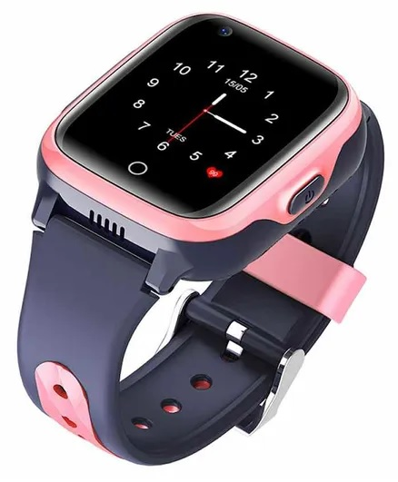

**TRACKO WATCHES**

GPS SMARTWATCHES FOR KIDS

DIGITAL MARKETING CAMPAIGN

**REPORT SUBMITTED BY:**

G POORNIMA

PARUCHURI RENU SREE

ROHAN NATHANI

RAHBAR ALI

**CONTENTS**

1. Project topic & URL of the blog
2. The business model
3. Description of the site/blog
4. How the site/blog will generate revenue
5. Digital Marketing campaigns
6. Measurement of the campaign performance
7. References
8. Unique contribution of each group member
9. **PROJECT TOPIC AND URL**

The business we have considered for our Project is Manufacturing and Selling of GPS smartwatches for kids. We will be carrying out Digital Marketing Campaign for our business with the objective of creating brand awareness and building web traffic. We will roll out Google Ad, Facebook Ad, LinkedIn Ad and You Tube Ad and measure the effectiveness of these campaigns through metrics.

<https://pgk5984.wixsite.com/trackowatches>

1. **BUSINESS MODEL**

We are in the business of manufacturing and selling GPS smartwatches for kids. The watch comes with various features like GPS based location tracking, Video and Audio calling capabilities, fitness apps, 72 hours lasting battery, waterproof design and many other features.

We would be selling these watches directly to consumers (D2C) through e-commerce using our own website. The watches will be sold at a 20% mark-up price including all costs, promotional expenditures, shipping & delivery charges and overheads.

**STP**

**Segment –** Parents in Tier 1 and Tier 2 cities who are in upper middle class and higher income bracket, who are educated and interested to invest in technology devices for self and children.

**Target –** We will be targeting customers who are searching for location tracking watch/smart watch/fitness watch for their children.

**Position –** We position ourselves as manufacturers and sellers of GPS Smartwatches at affordable prices.

**4Ps**

**Product –** GPS Smartwatch TrackO Premium, TrackO Kids, TrackO kids Premium

**Price –** Rs. 12,000/- to Rs. 15,000/-

**Place –** Home Delivery to customers in Bangalore as Phase1 strategy. Later expansion to Tier 1&2 cities.

**Promotion –** Through Website, Google Ad, Facebook Page, Facebook Ad, LinkedIn Page, LinkedIn Ad, YouTube Channel, YouTube Ad.

**Our Business Model**

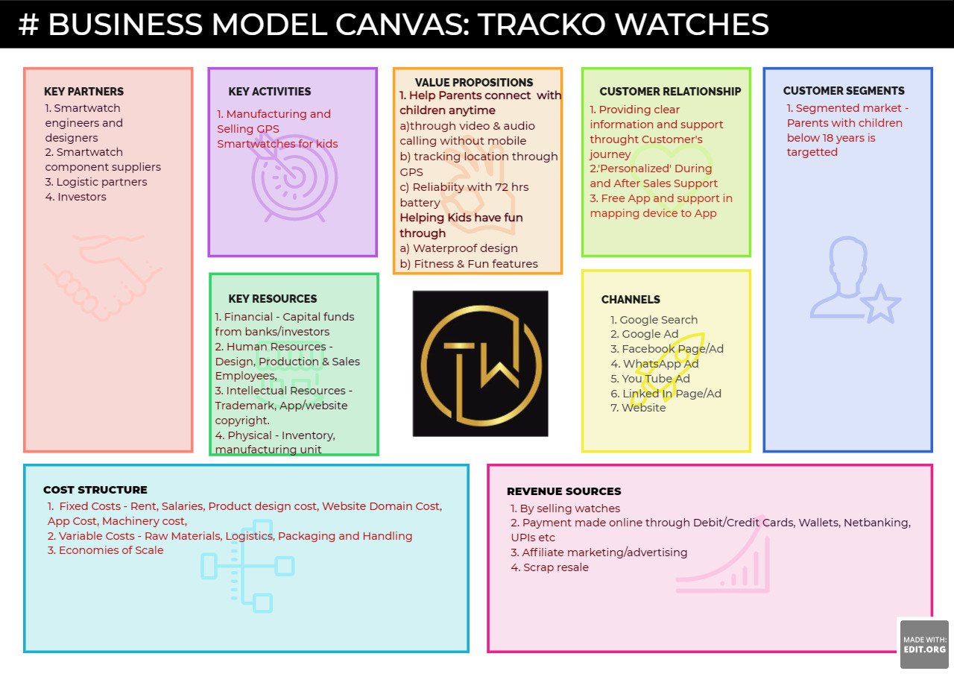

1. **DESCRIPTION OF THE SITE/BLOG**

Our blog is created using Wix.com website builder.

Our blog page consists of 4 sections, shown below.

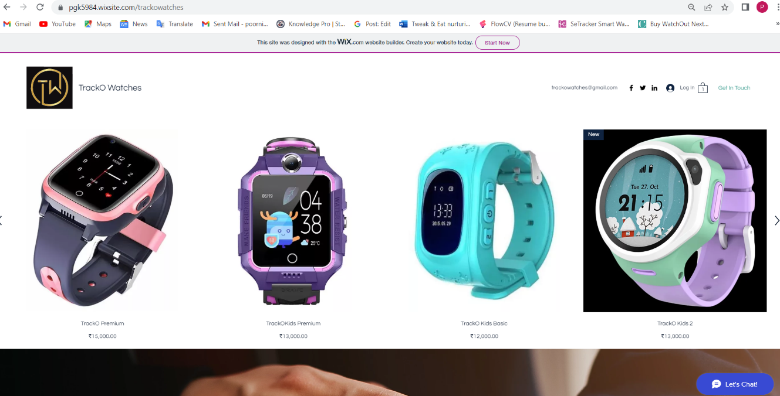

**Section 1** shows our Company Logo, our business e-mail, Facebook, Twitter and Linked-in Icons, Member Login, Cart and Get in Touch buttons.

**Section 2** shows our list of products (Watches) with Product Name and Price. Upon clicking the product images, it navigates to another page where we can see alternate views of the watch, features offered, SKU information, alternate designs in the price range, etc.

One can click on an image and Add to Cart.

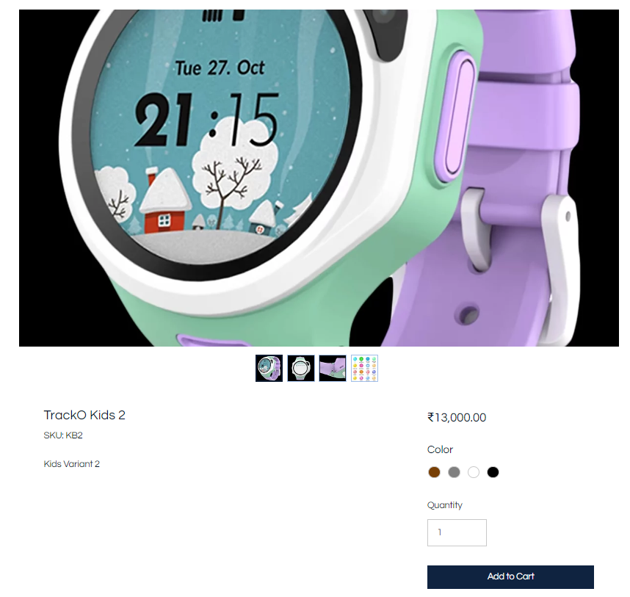

**Section 3** has story content explaining the idea behind our business and how our product is a reflection of our endeavour to fulfill the need of our Target Segment.

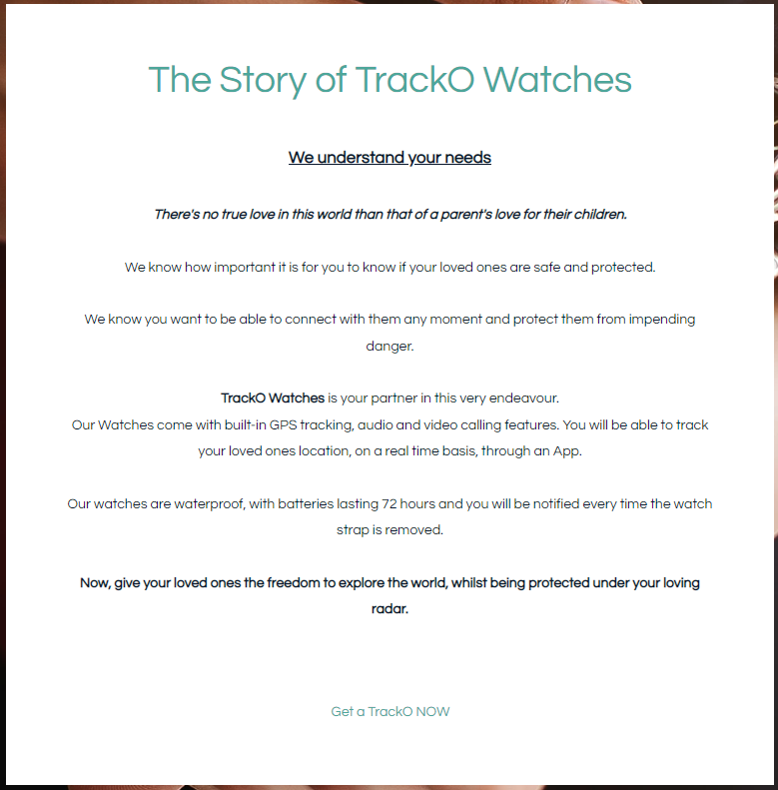

**Section 4 –** Allows customers to leave a comment and connect with us.

This section also acts as a simple lead generation form.

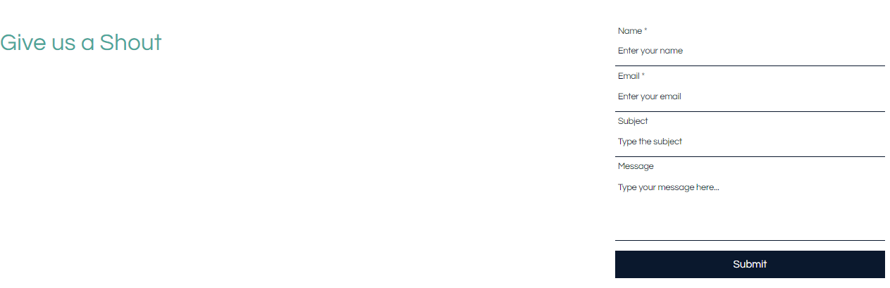

**At the end of the page** is a Google Map showing the location of our company, copyright details and contact number of our Business and links to our social media accounts.

1. **HOW THE SITE WILL GENERATE REVENUE**

The site will generate revenue through Sale of the Watches listed in the website.

Once our business gains momentum, we will generate revenue through selling Ad Space, affiliate marketing etc.

**Revenue generation through Sale of Watches**

* 1. Once a customer visits the website, selects a product for purchase, the product is added to the shopping cart.

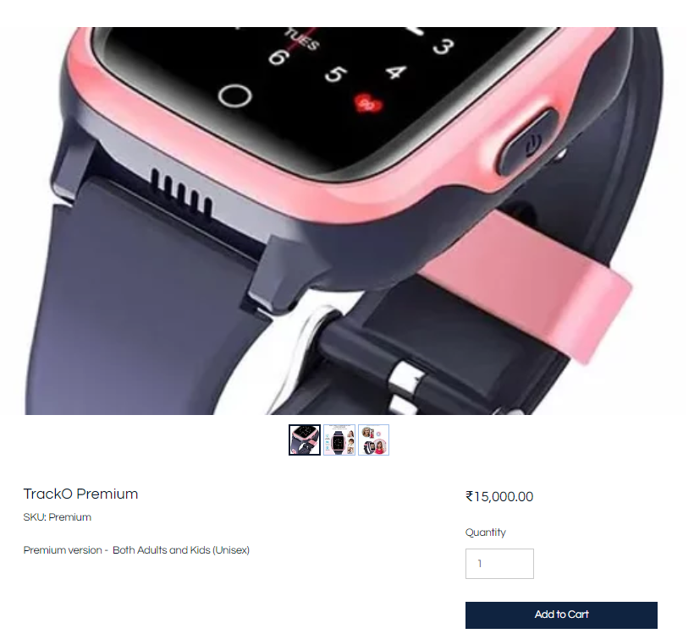

* 1. After selecting all the products that the customer wants to purchase, he can click on the Cart and view the items in the cart.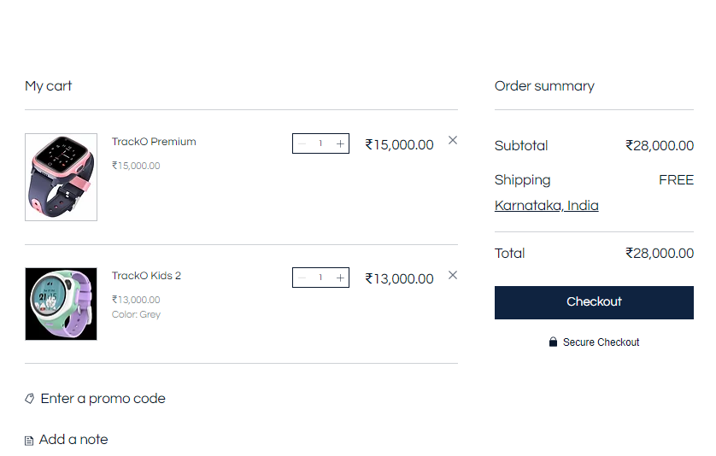
  2. Customers can close the purchase by clicking on the Checkout button which will show a list of payment methods.
  3. Once they select a payment method, corresponding details are gathered and payments are routed through payment gateways to our merchant account.

Once the payment is received, shipping of the product is initiated and delivered to the customer to the address provided by the customer.

1. **DIGITAL MARKETING CAMPAIGNS**

We will be promoting our business through Google Ad, Facebook Ad, Youtube Ad and LinkedIn Ad.

The Objective of our Campaigns is to create awareness about our business and drive traffic to our website.

Our Company’s website – <https://pgk5984.wixsite.com/trackowatches>

Our Company’s gmail id is [Trackowatches@gmail.com](mailto:Trackowatches@gmail.com)

Our Linked In Account is **TrackO Watches** and LinkedIn Page is **TrackO Watches**

Our Facebook Account is <https://www.facebook.com/profile.php?id=100084379754490>

Our Facebook Page is <https://www.facebook.com/trackowatches/>

Our Youtube Channel is **TrackO Watches**

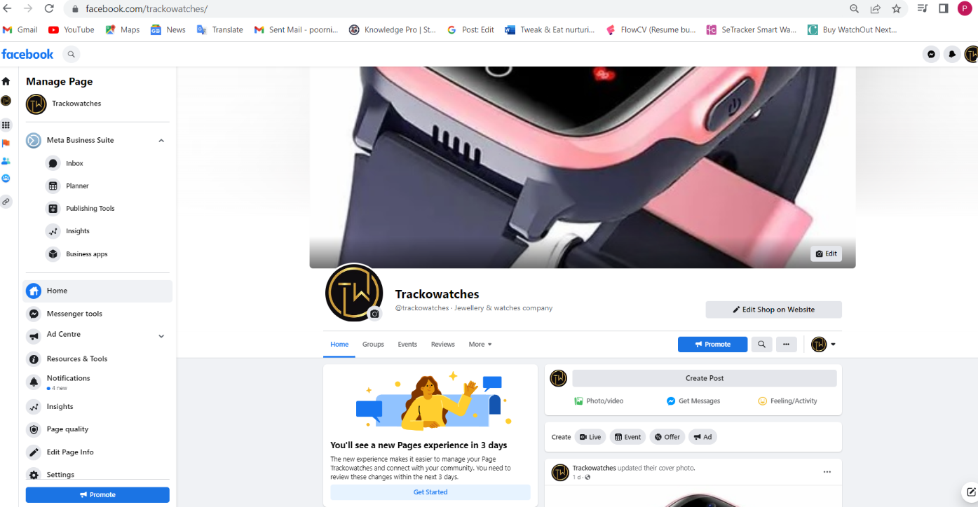

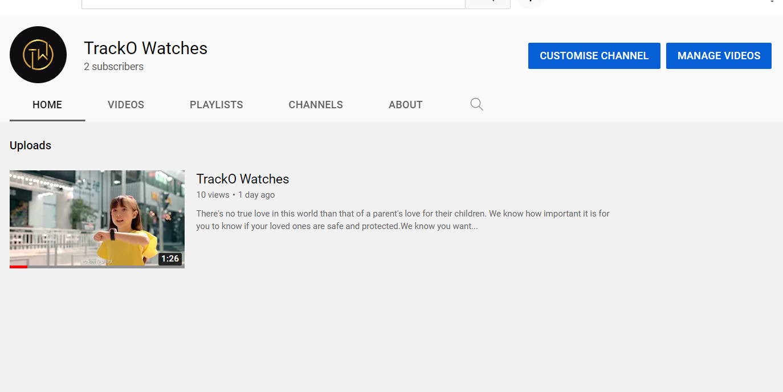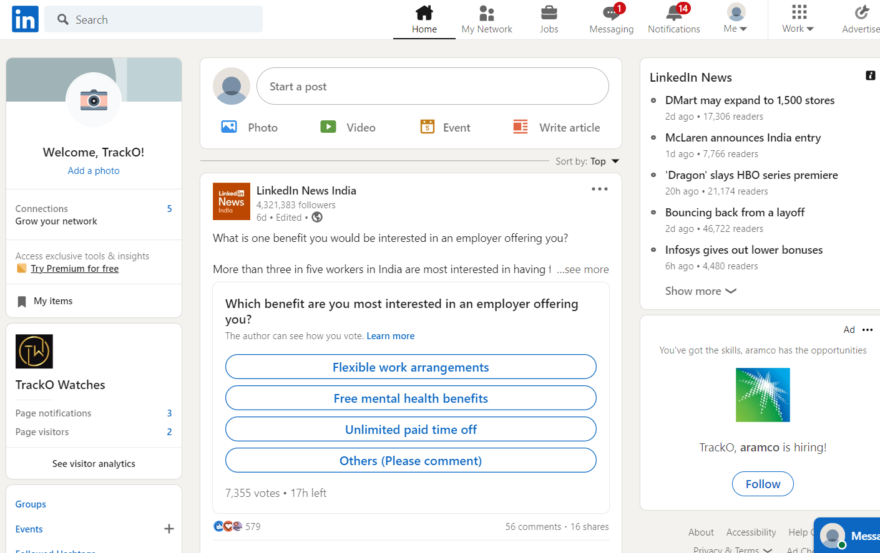

The following screenshots show the process followed in the creation of various digital Ads and preview of the Ads.

**5.a)**  **Screenshots of Google Ad Advanced**

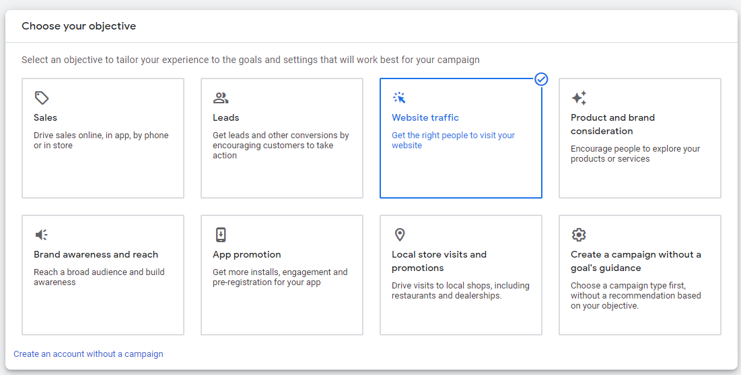

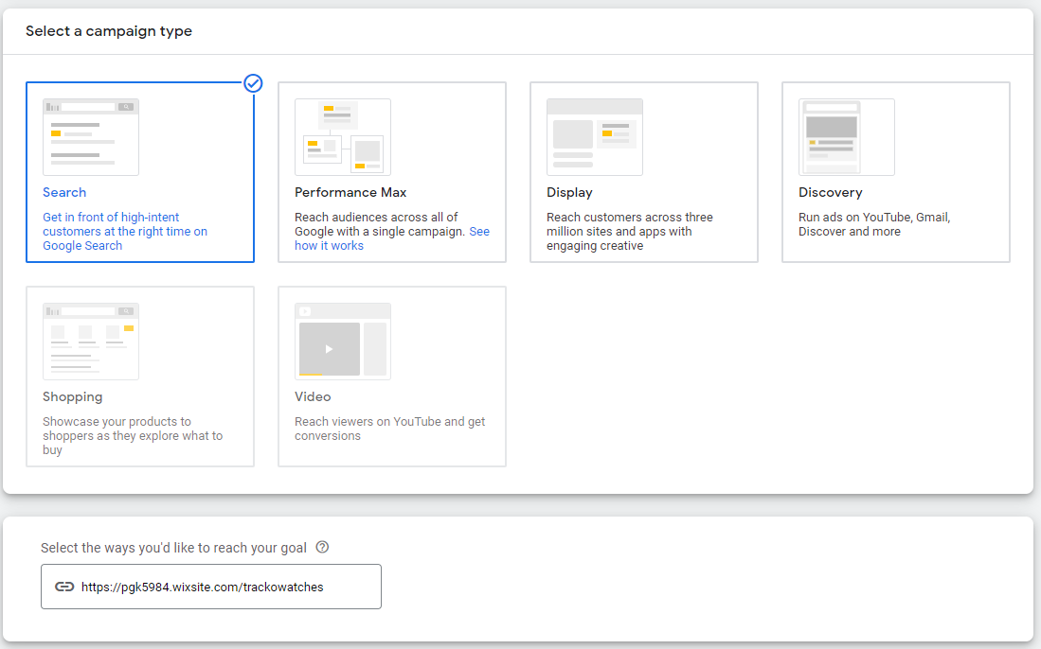

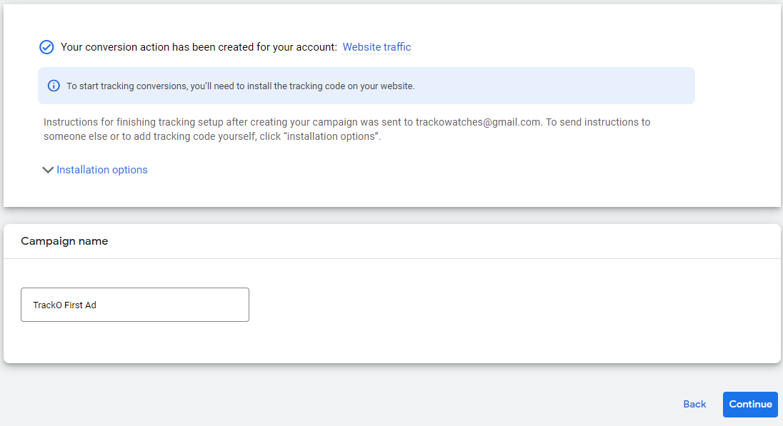

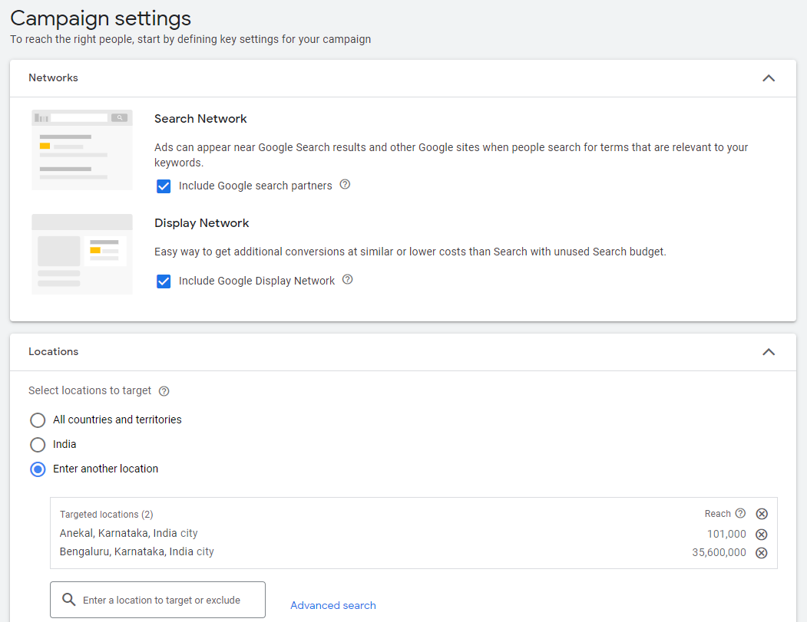

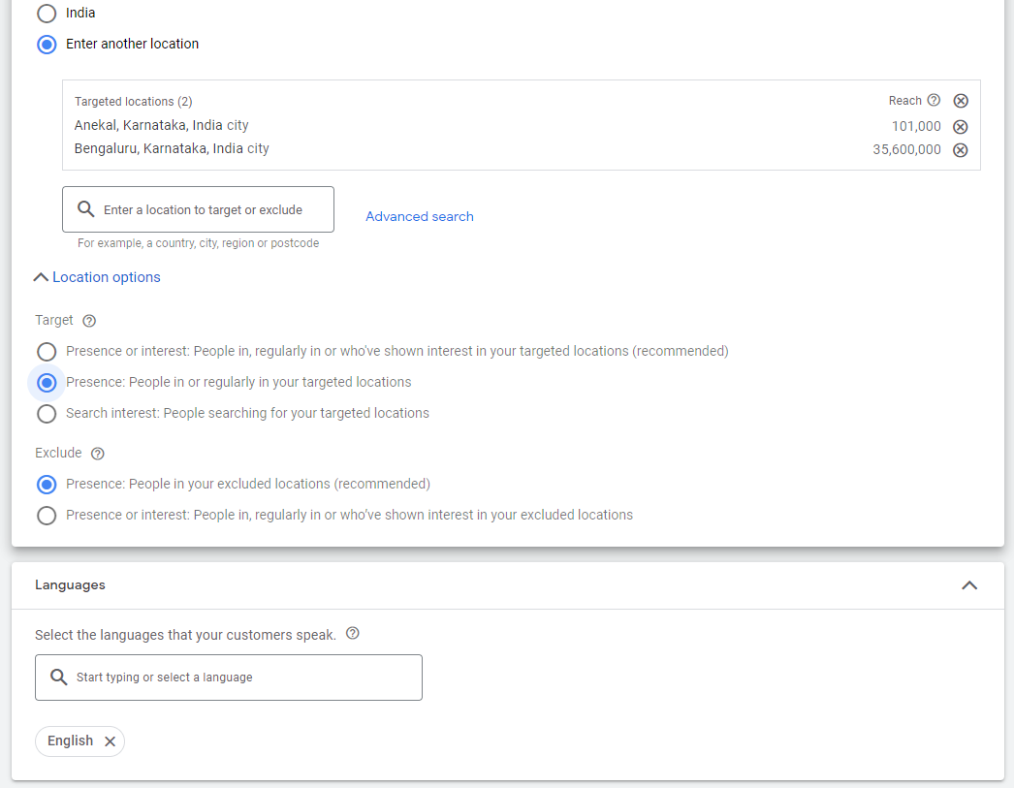

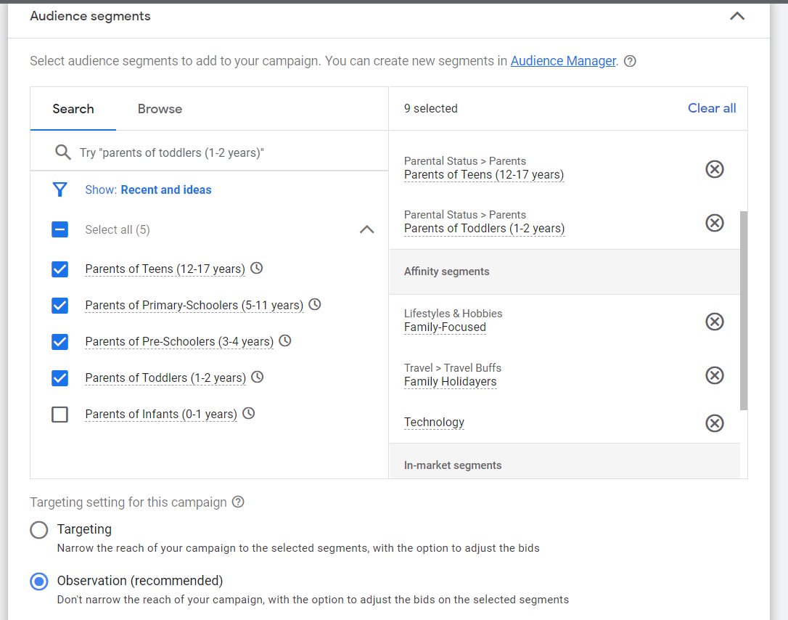

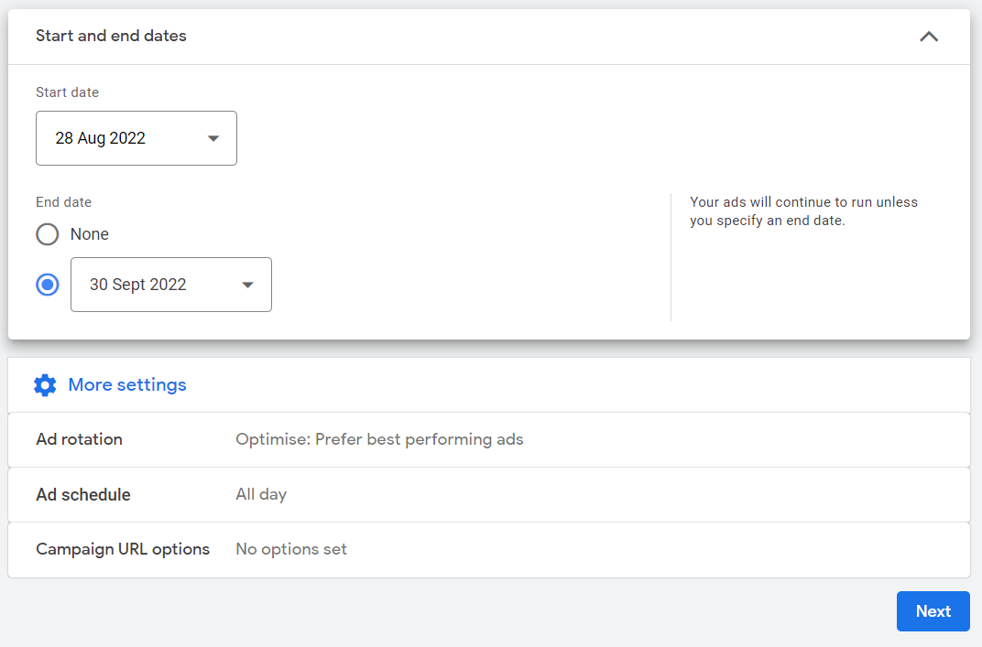

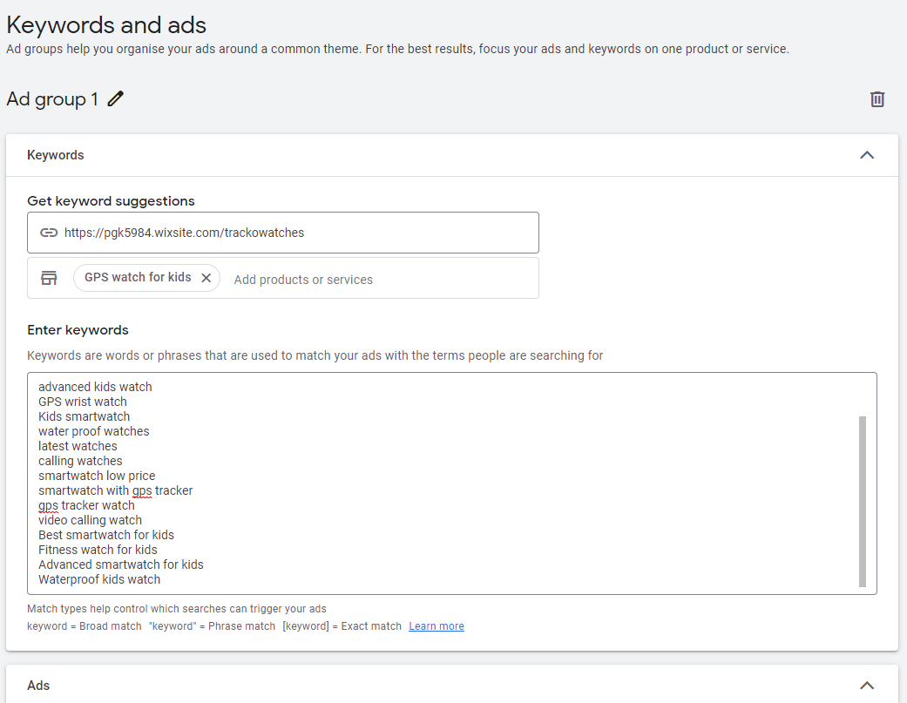

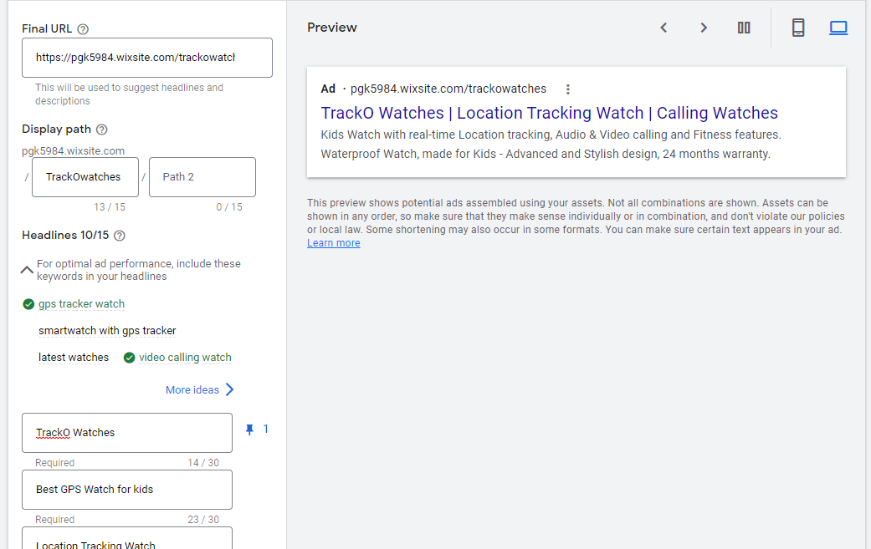

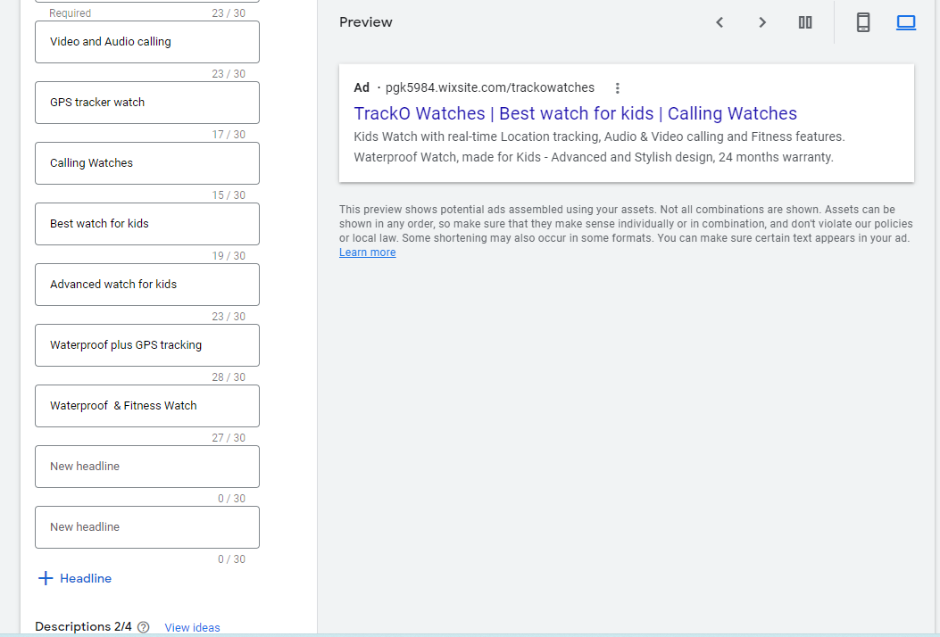

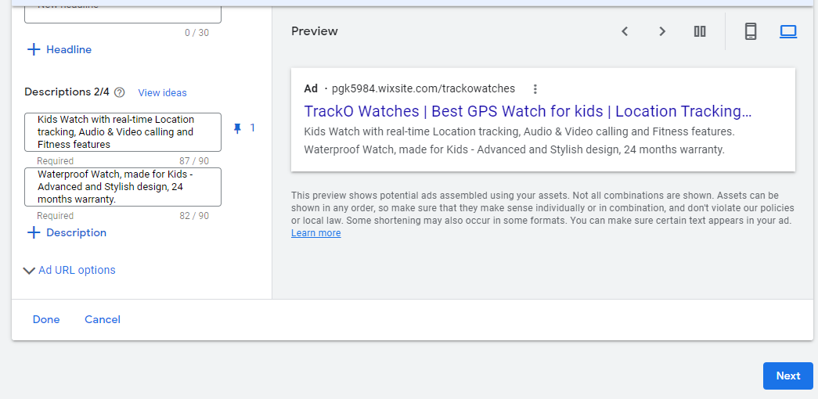

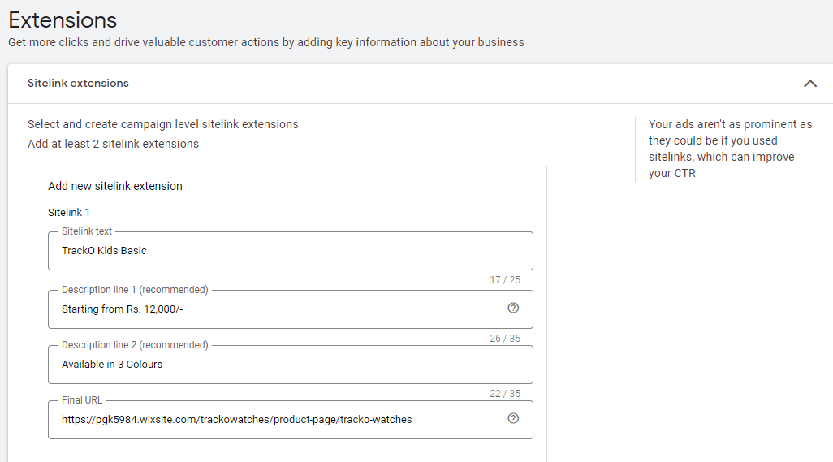

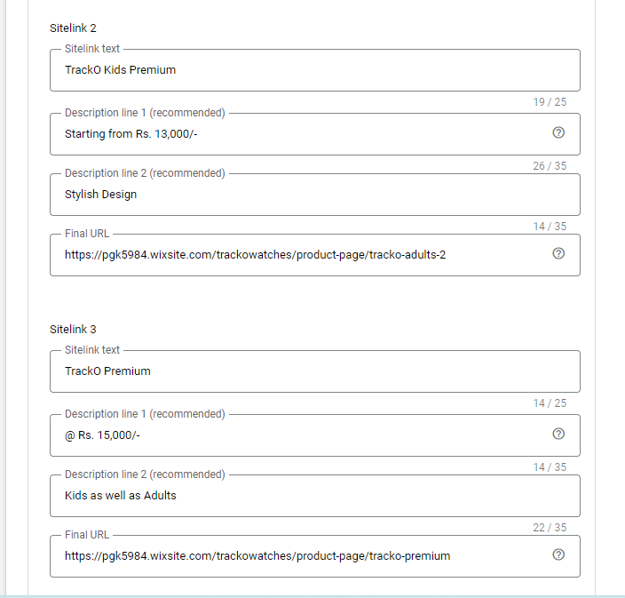

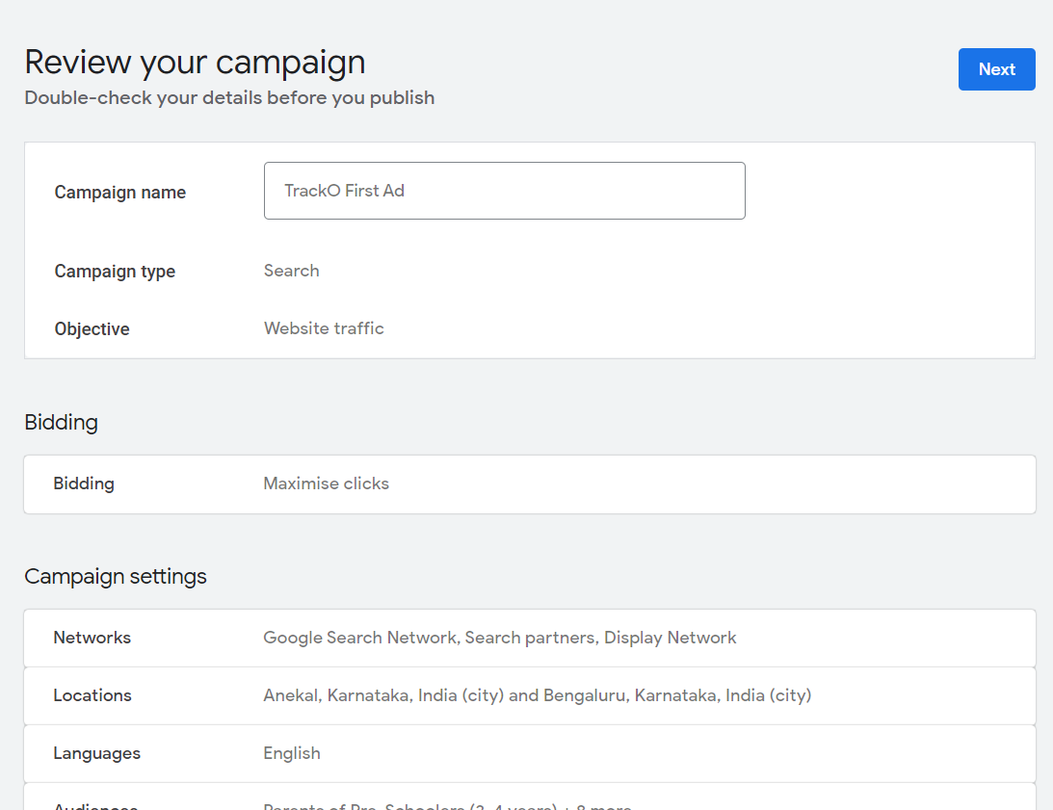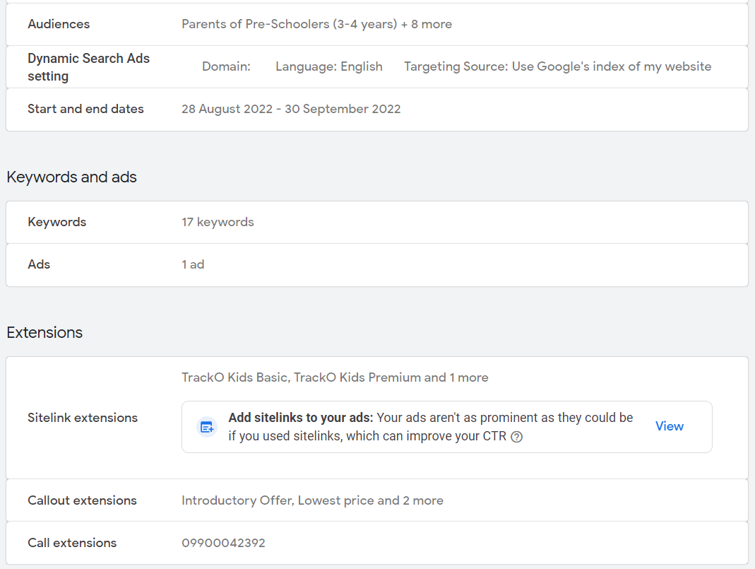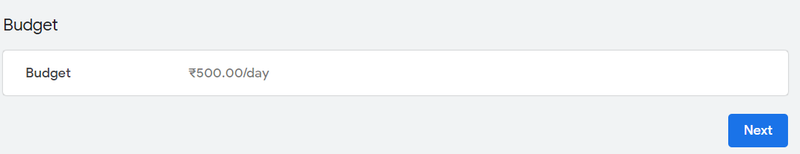

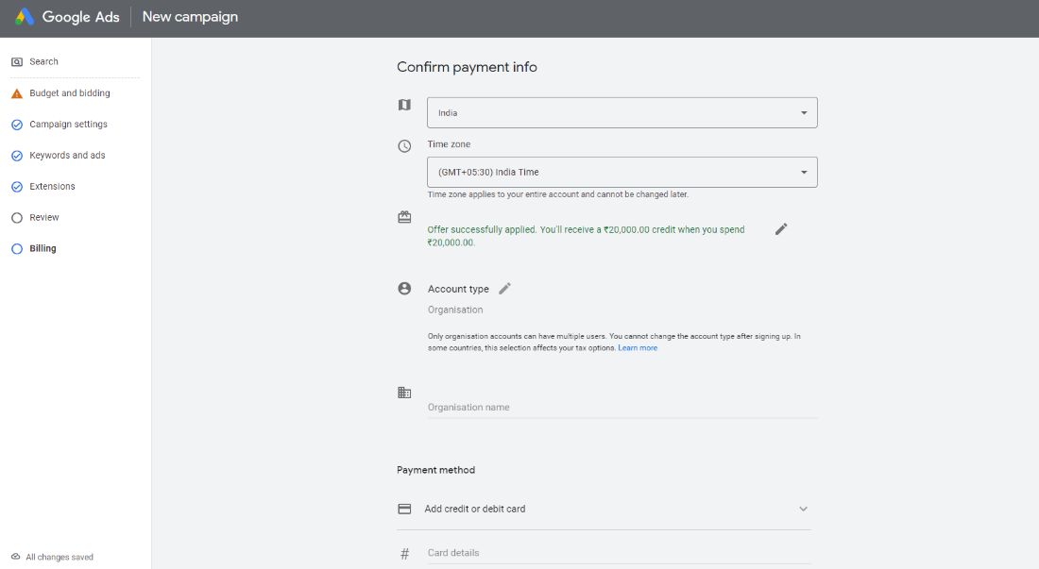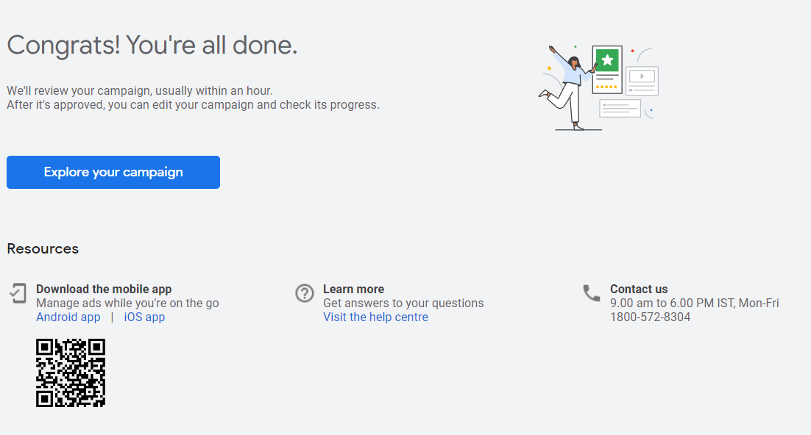

**Preview of the Google Ad**

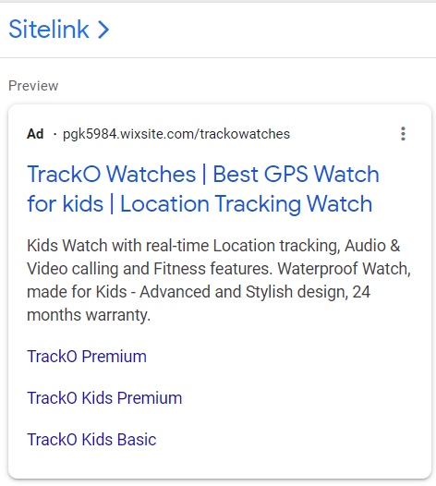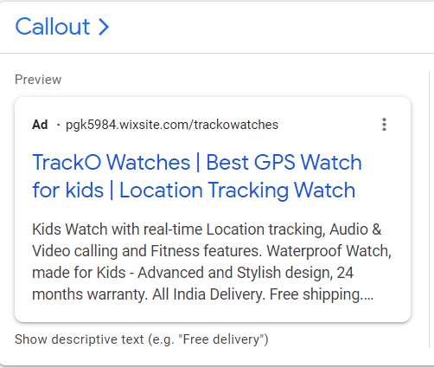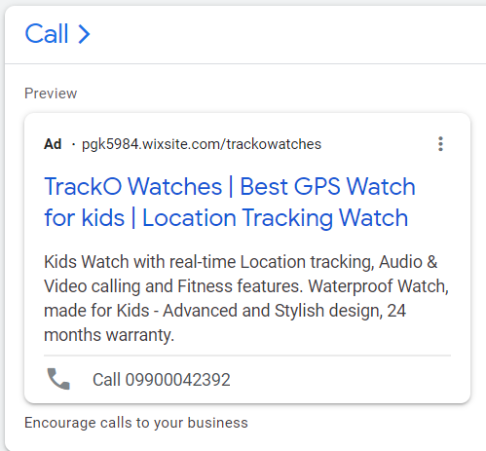

**5.b)** **Screenshots of YouTube Ad**

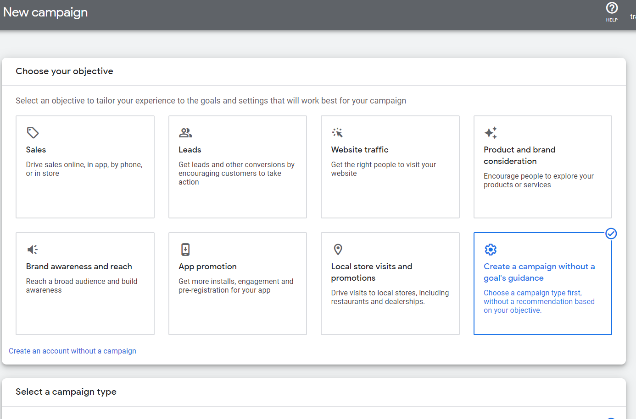

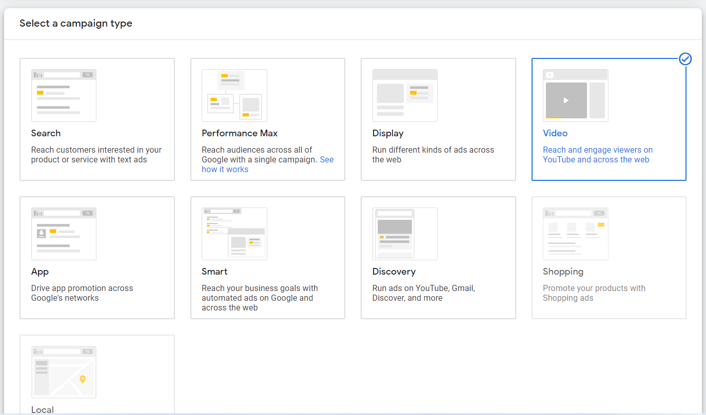

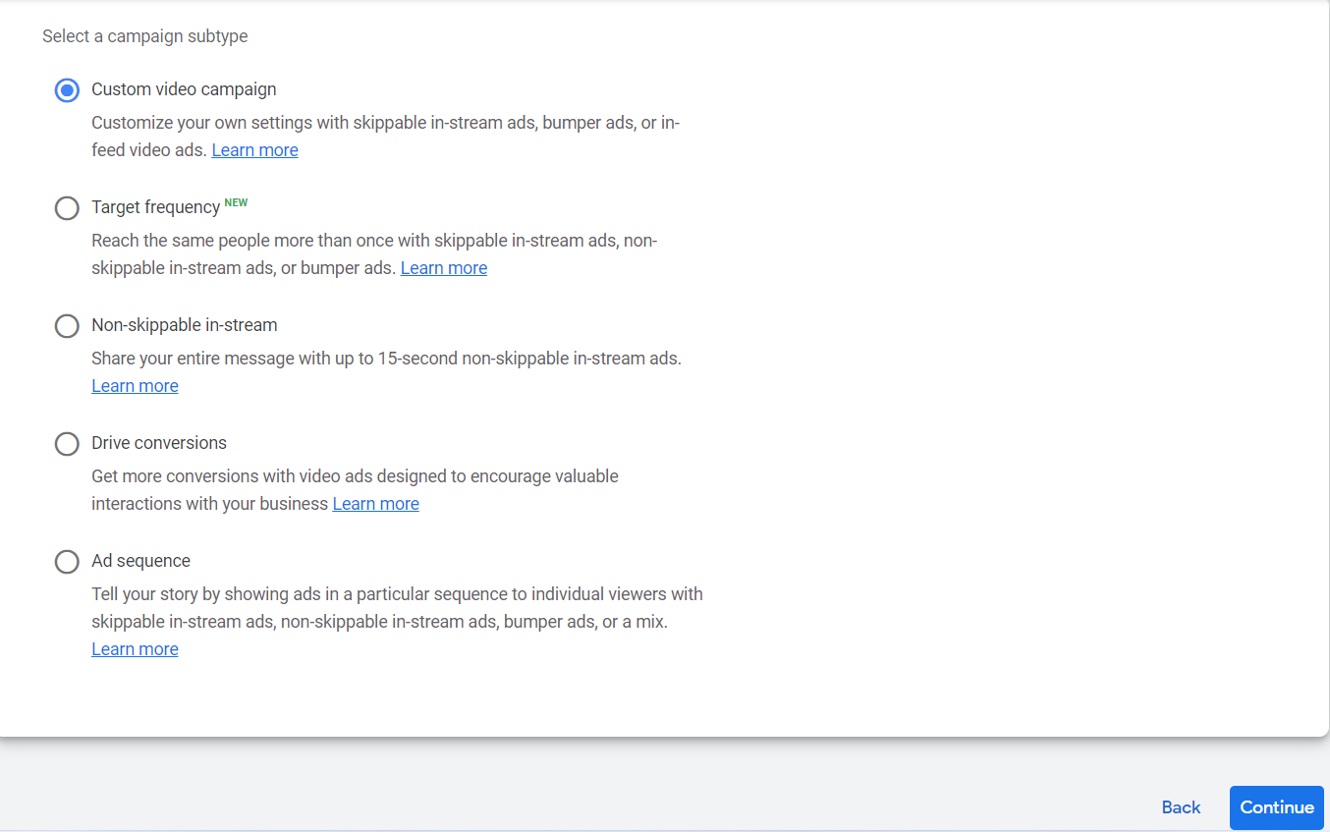

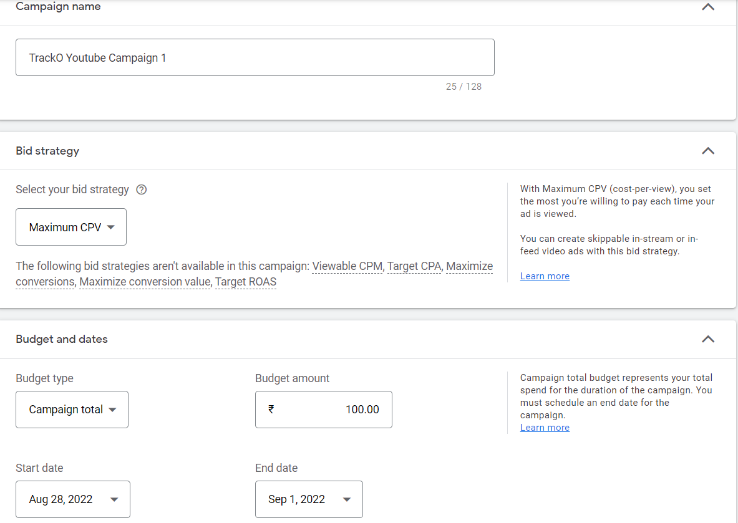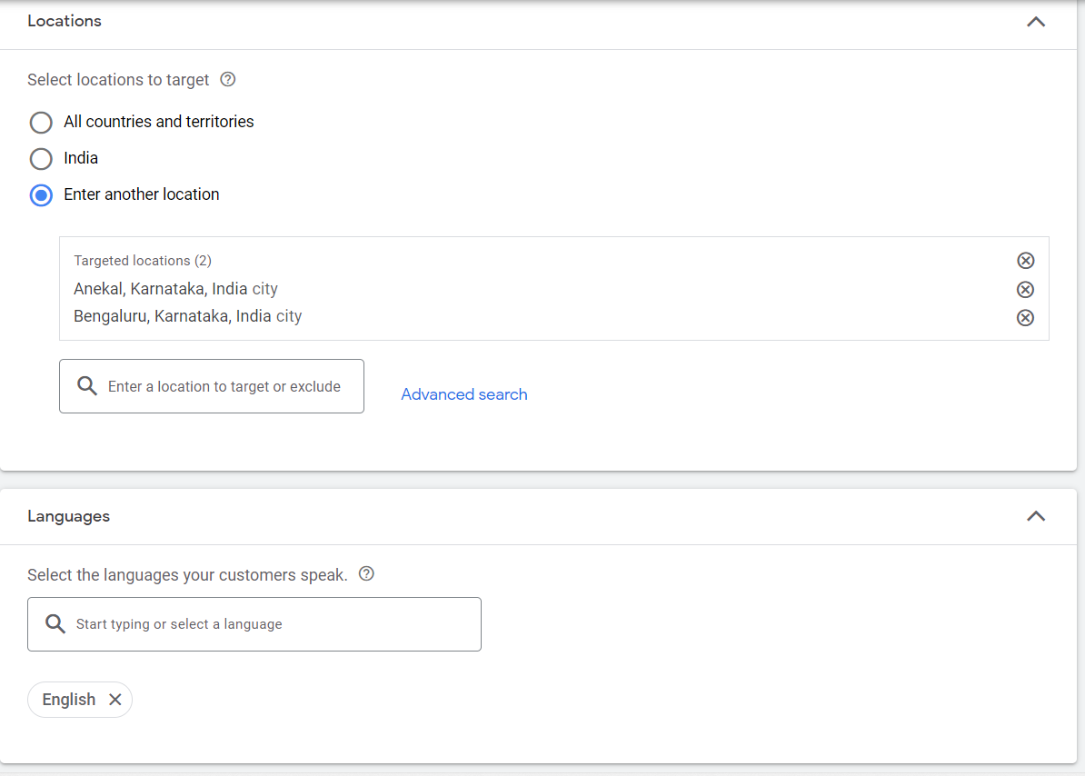

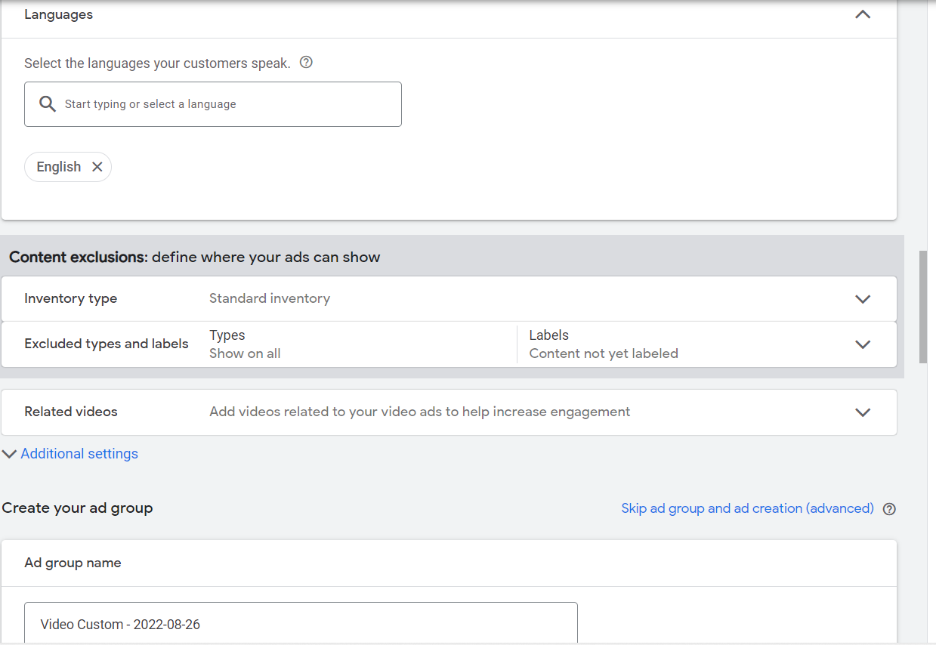

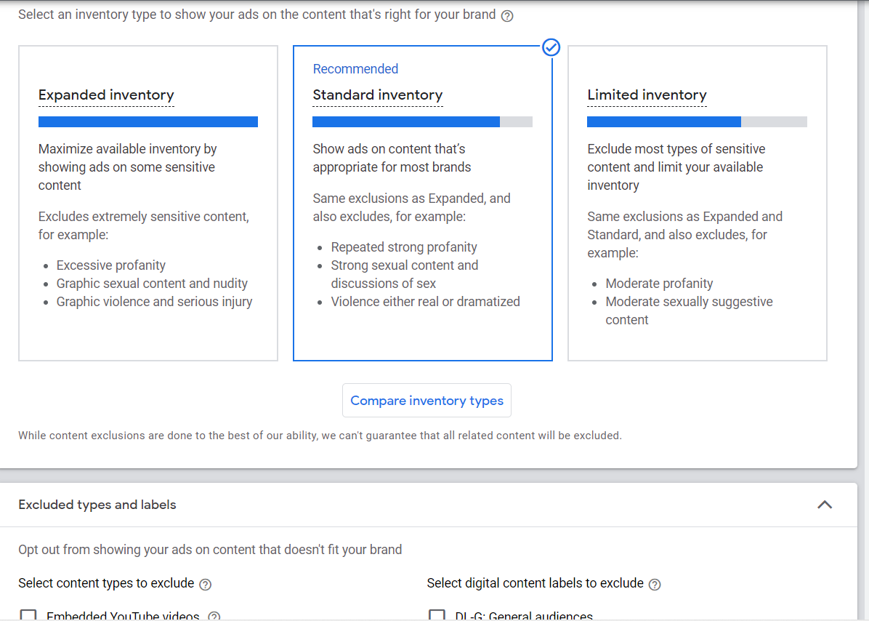

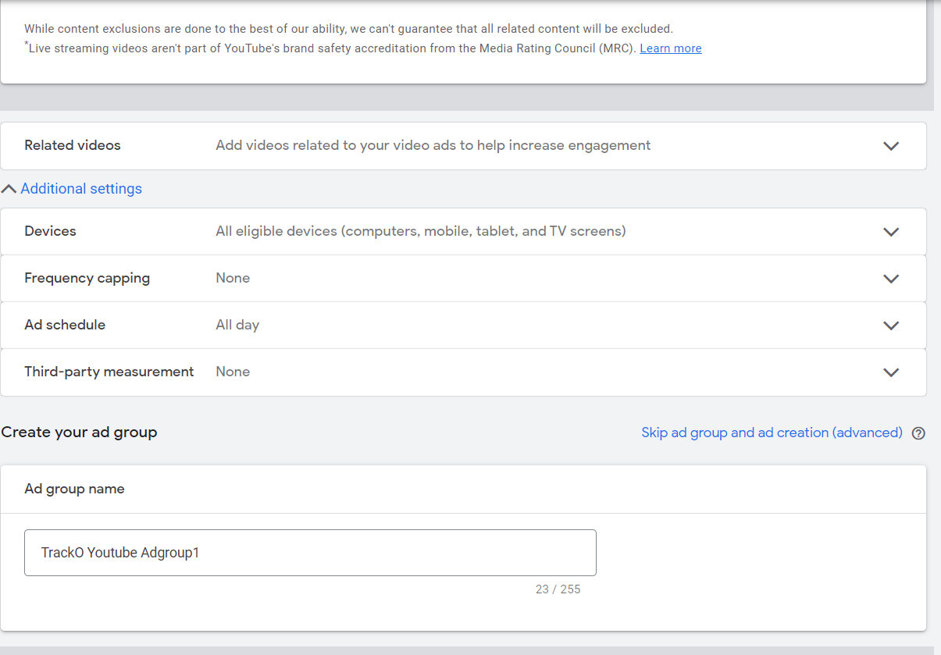

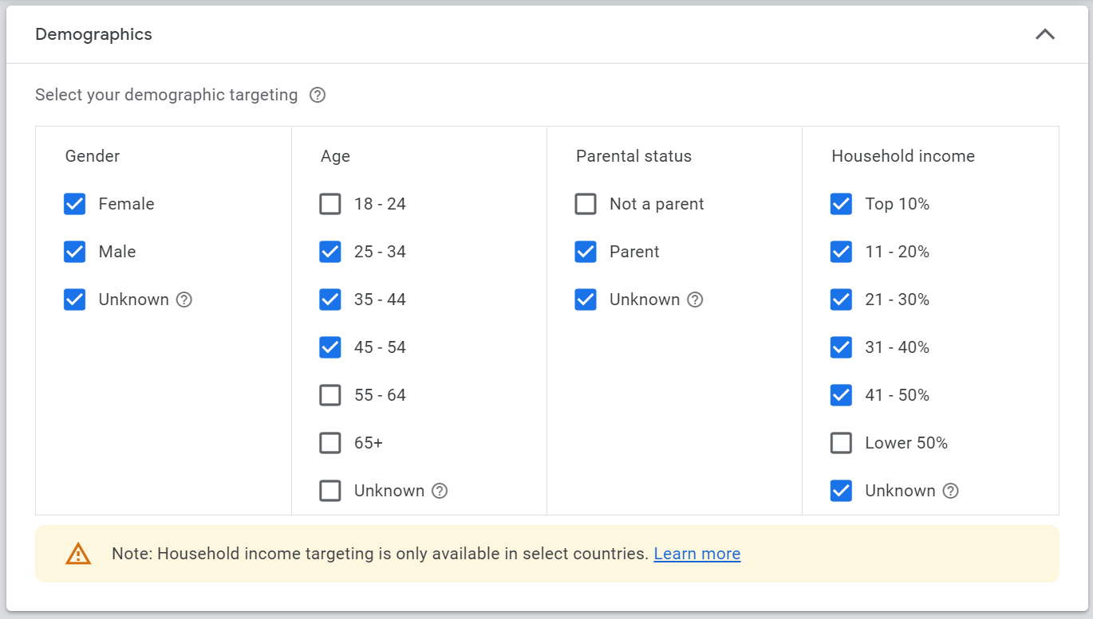

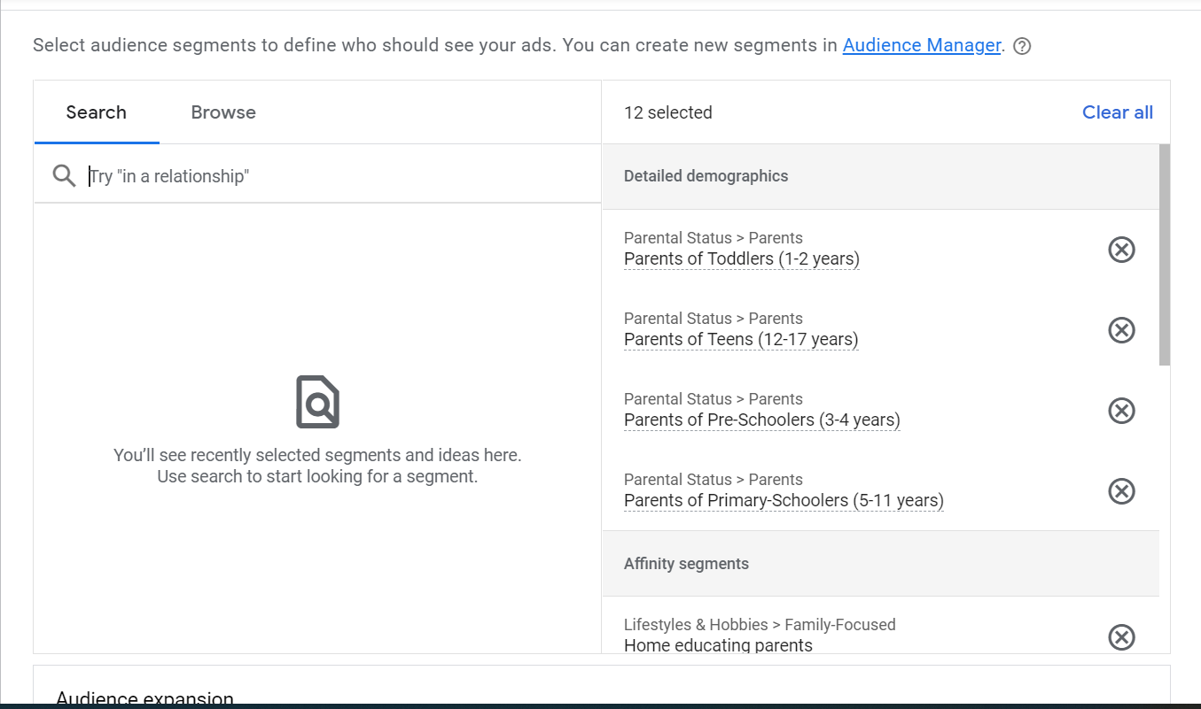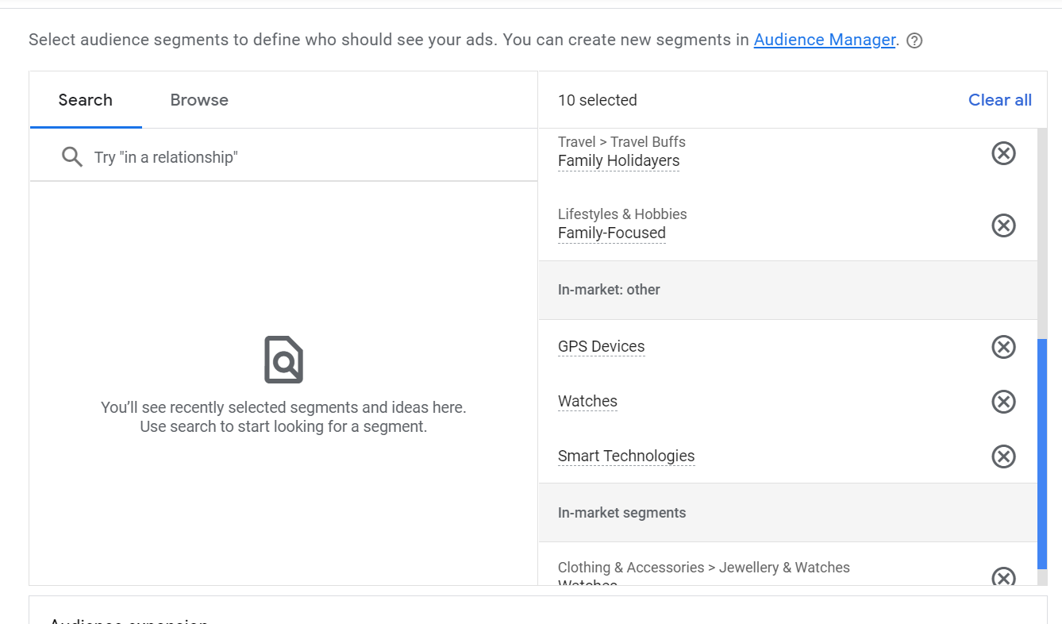

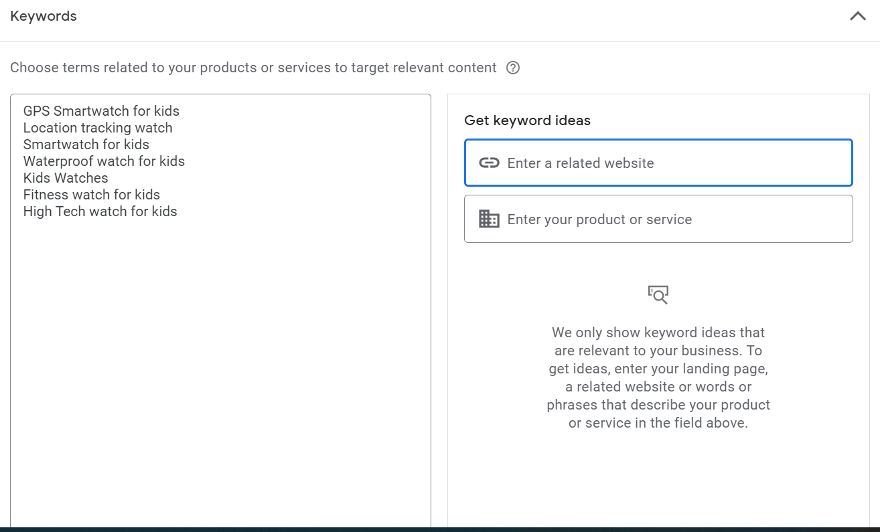

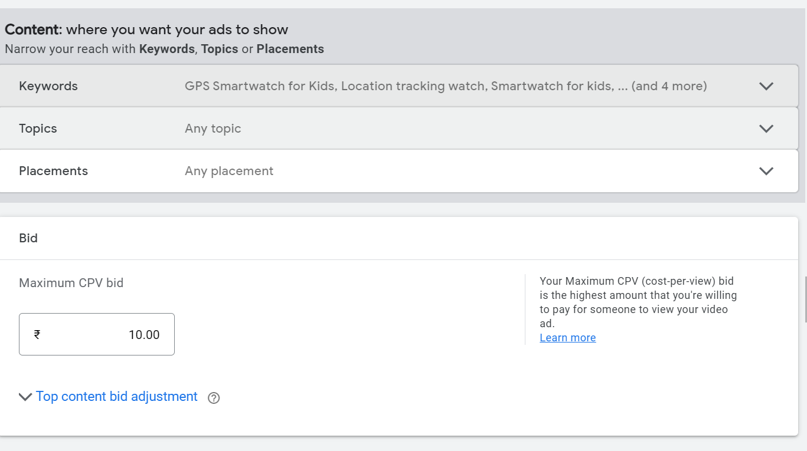

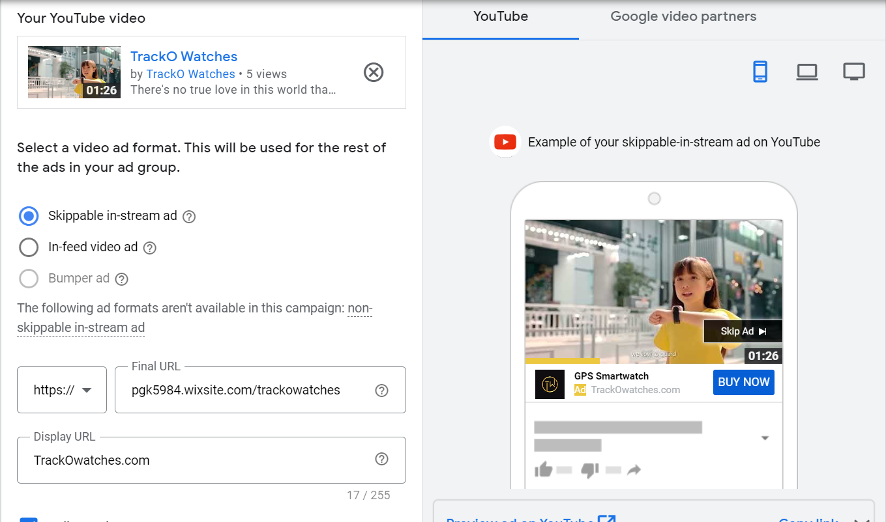

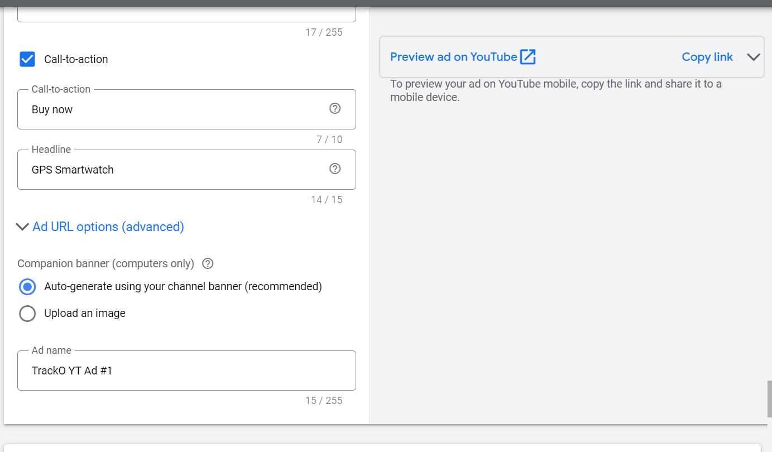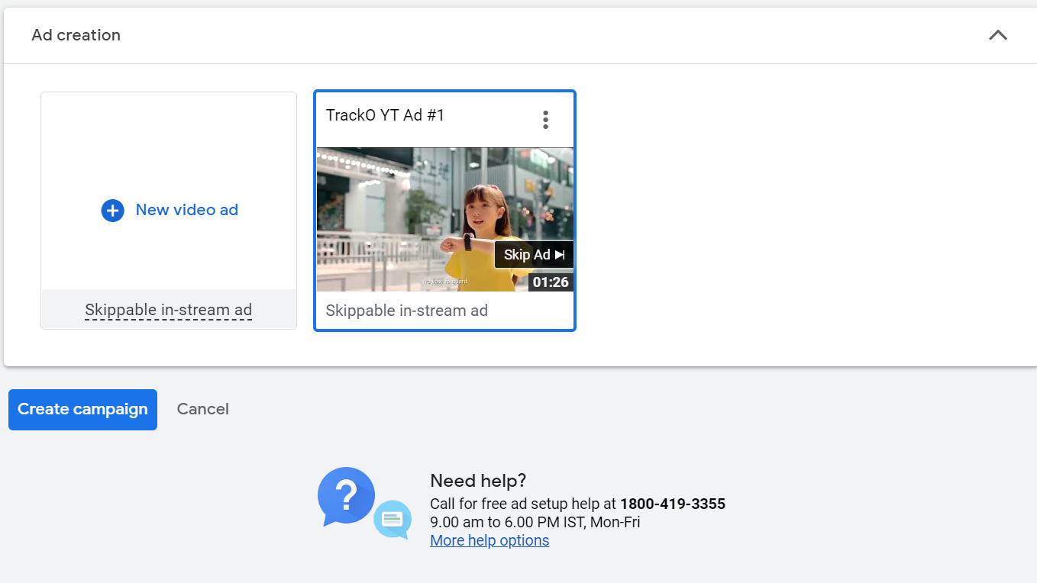

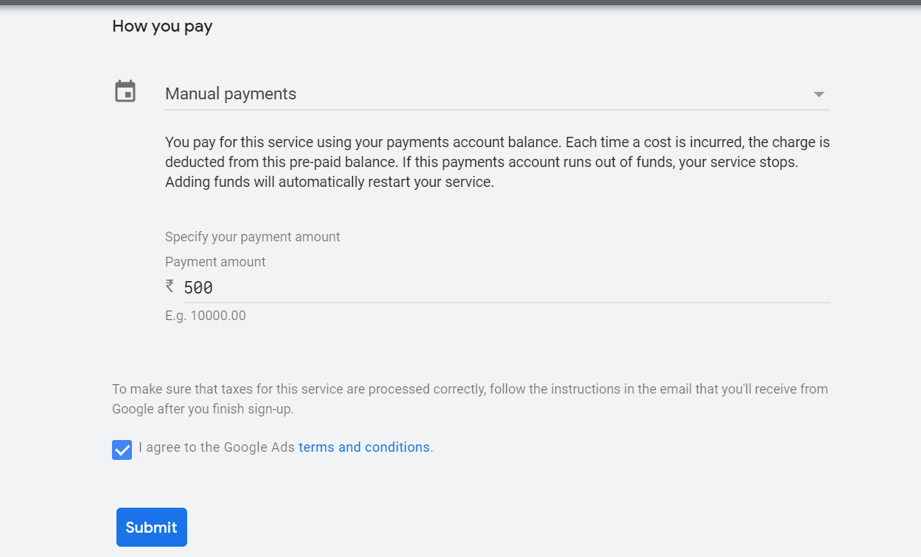

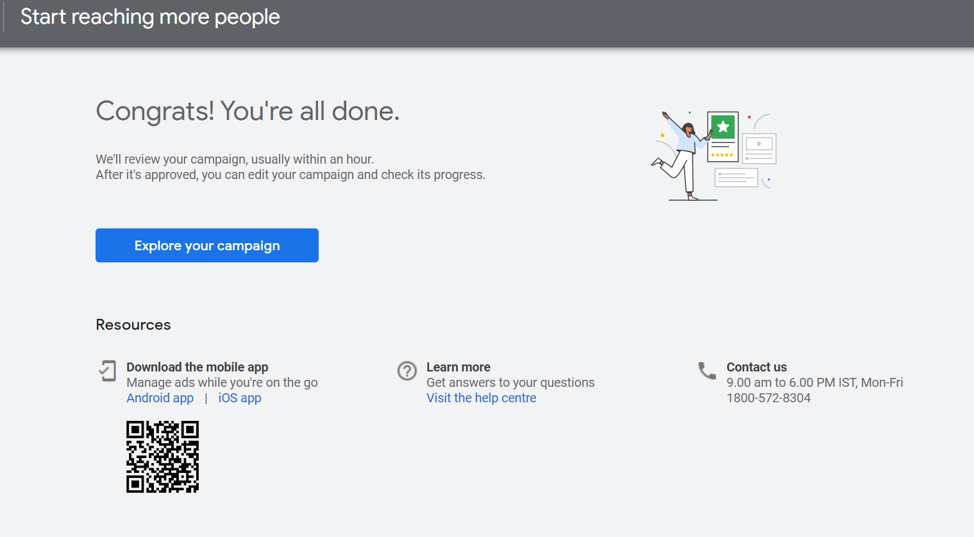

**Youtube Video Ad Link**

[Google Ads :: Video preview demo](https://www.youtube.com/watch?v=VSCkrvtVt3Y&force_ad_encrypted=AD7yQuLLAqnYROy8OtjElROAcDFRgaRTAPRvfNFlhiAIzlq8m5HoXmH4PLsWtPjoZRJ88BahbYEZjXnwoRhlsfTqCbrhGv4GYJ06Vvlgcewz4QV8xlgiDTLYv0FrGjlTf1FUvnMfhzCqiWt3rAQn2BbQU7XMjEzKJPiVlJkK-DQNkTV1_RvoElFwJ9aqxYxRwlPmrtkN_qEBq2arq5NDtNq2MICCDTVaazSjvPWkJyO63aK92HOBYgoE6j_VcZWIa8DT4ulkmaiUCVEWomnNH5-sZgdtfphNC1GtcxbZkjRlE8V5Z0A4Yleyw1mSfKTojrksRbmb24dm84qNB53GraMOPp6iWZXuiCI6hMhNb--RZVP5ias_L8ubbTb9KDSaxbSpsm5RhXxOuG8WVohnaQ-N9L5D6C-aWm2DLzFtqO4QKeBBoFuDdFxFv4nX_R5BGqAa0XDmv4xfYH_ozKbwpOkbQfLS_sNdErAw_tfswFDzpSVeln3J2yg9Kso6oSFwefpExzhEUZ7jwCwgXpNOHcrY75fyuZ13VX2CRpGRb9pQ8Xzg0fJ6A2_7A0ORKZawhMBLgC_yBPHFMW-bLXrRWsX1GsOVg_y6C50yR5zXKHfT-a2sujQKkI1cajUMLdCjnhMOpd3L3sqgDpyZsn94G1XKjoaaWikCrnAi5WFo215HyXBJS0Hlwj8%3D)

<https://www.youtube.com/watch?v=VSCkrvtVt3Y&force_ad_encrypted=AD7yQuLLAqnYROy8OtjElROAcDFRgaRTAPRvfNFlhiAIzlq8m5HoXmH4PLsWtPjoZRJ88BahbYEZjXnwoRhlsfTqCbrhGv4GYJ06Vvlgcewz4QV8xlgiDTLYv0FrGjlTf1FUvnMfhzCqiWt3rAQn2BbQU7XMjEzKJPiVlJkK-DQNkTV1_RvoElFwJ9aqxYxRwlPmrtkN_qEBq2arq5NDtNq2MICCDTVaazSjvPWkJyO63aK92HOBYgoE6j_VcZWIa8DT4ulkmaiUCVEWomnNH5-sZgdtfphNC1GtcxbZkjRlE8V5Z0A4Yleyw1mSfKTojrksRbmb24dm84qNB53GraMOPp6iWZXuiCI6hMhNb--RZVP5ias_L8ubbTb9KDSaxbSpsm5RhXxOuG8WVohnaQ-N9L5D6C-aWm2DLzFtqO4QKeBBoFuDdFxFv4nX_R5BGqAa0XDmv4xfYH_ozKbwpOkbQfLS_sNdErAw_tfswFDzpSVeln3J2yg9Kso6oSFwefpExzhEUZ7jwCwgXpNOHcrY75fyuZ13VX2CRpGRb9pQ8Xzg0fJ6A2_7A0ORKZawhMBLgC_yBPHFMW-bLXrRWsX1GsOVg_y6C50yR5zXKHfT-a2sujQKkI1cajUMLdCjnhMOpd3L3sqgDpyZsn94G1XKjoaaWikCrnAi5WFo215HyXBJS0Hlwj8%3D>

**5.c)** **Screenshots of Facebook Ad**

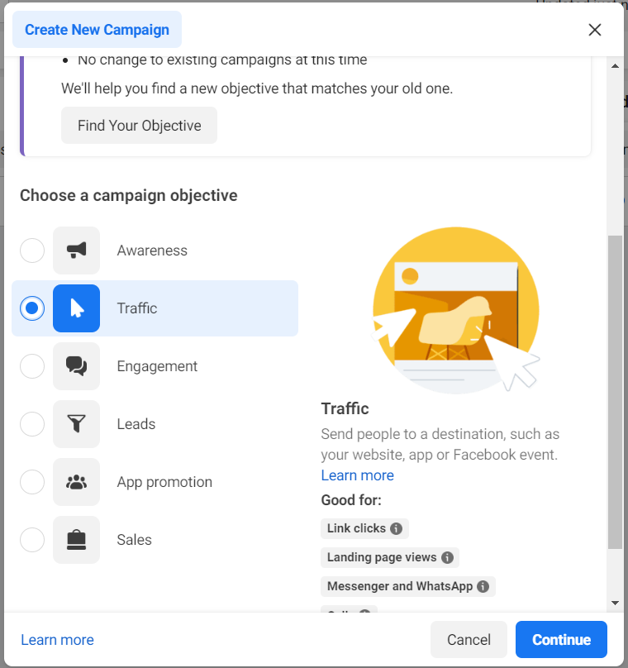

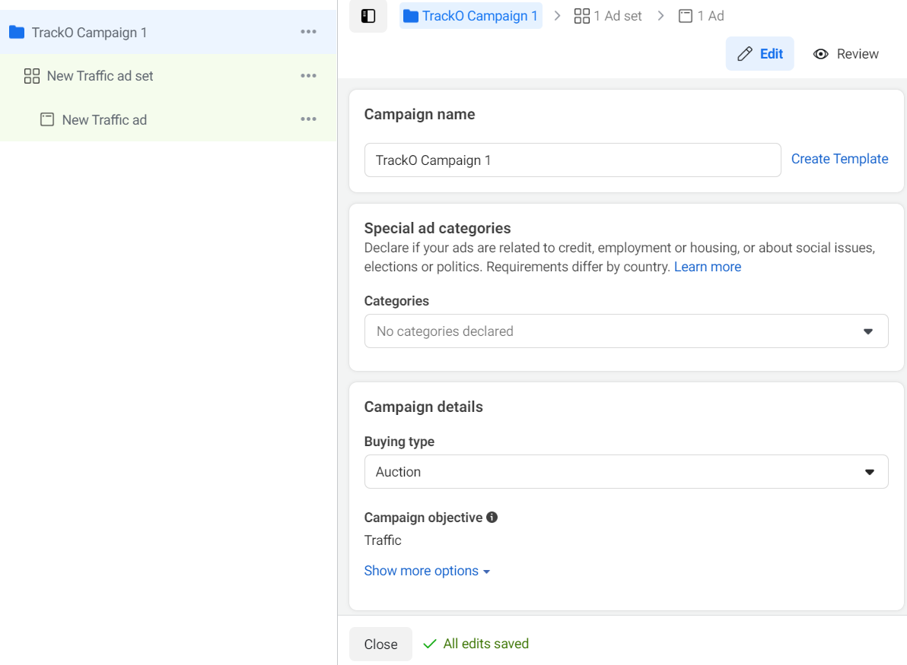

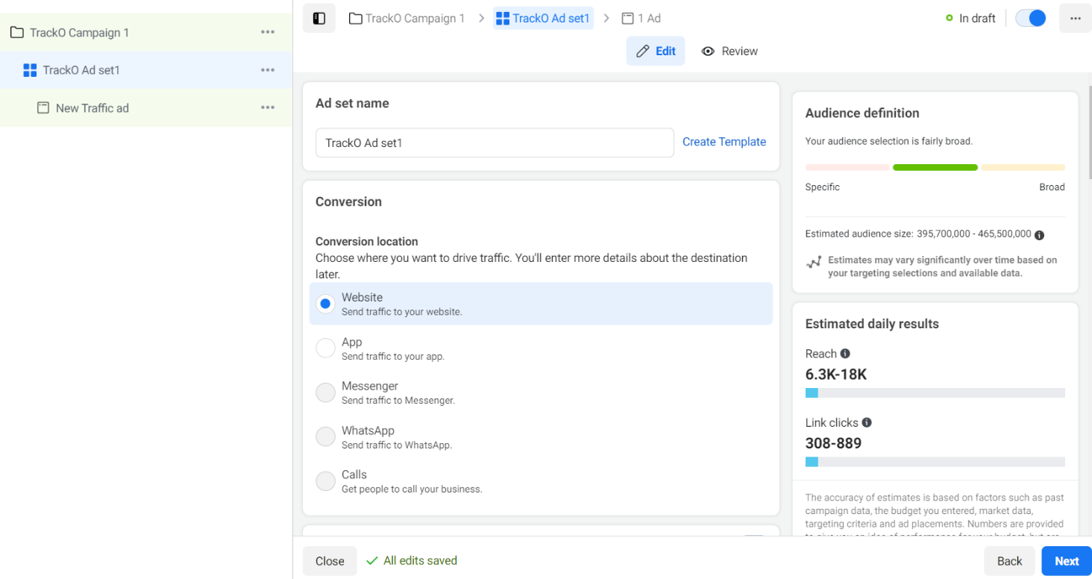

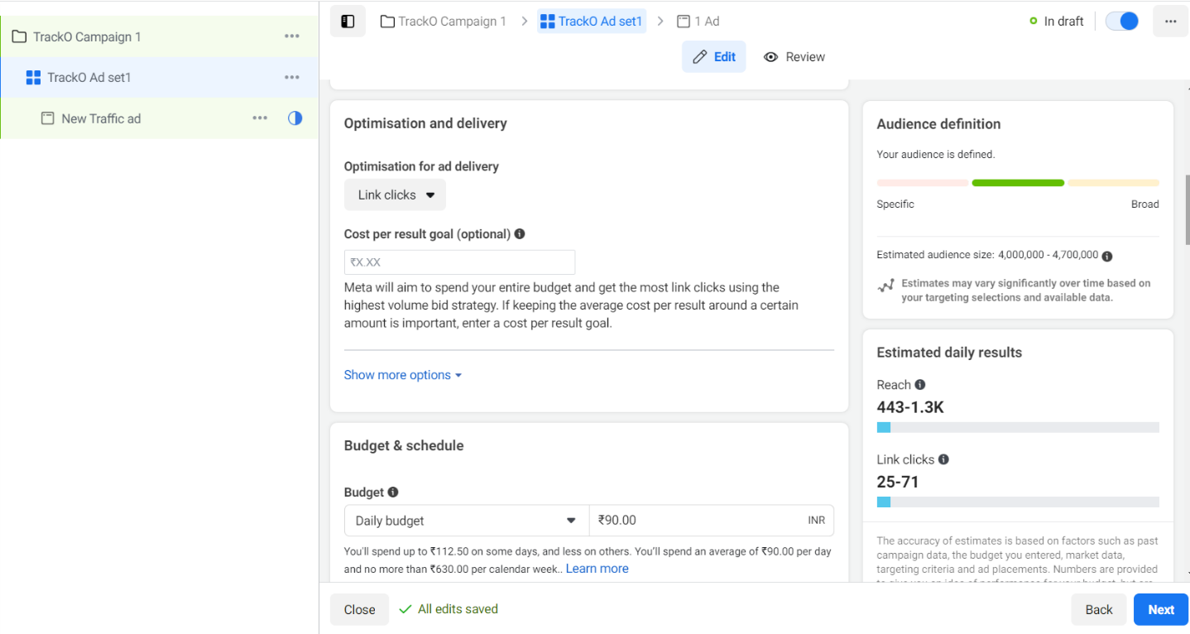

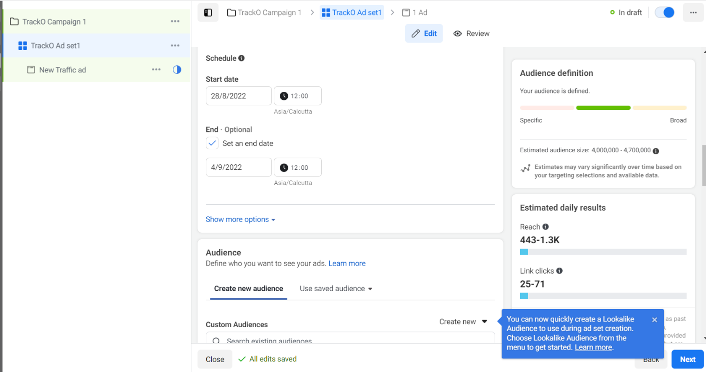

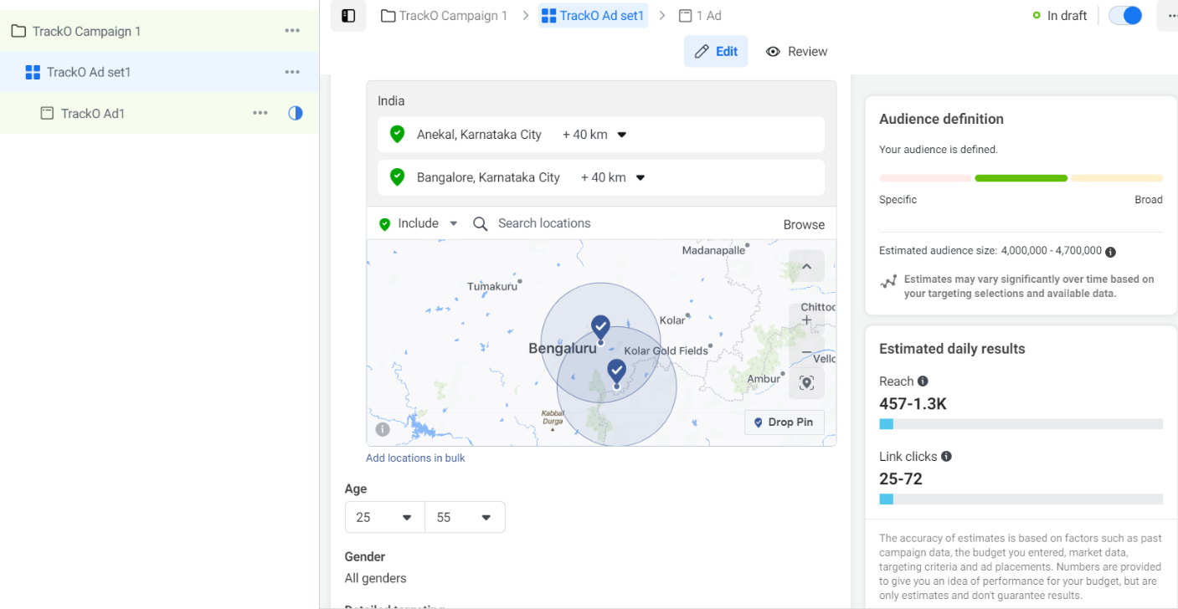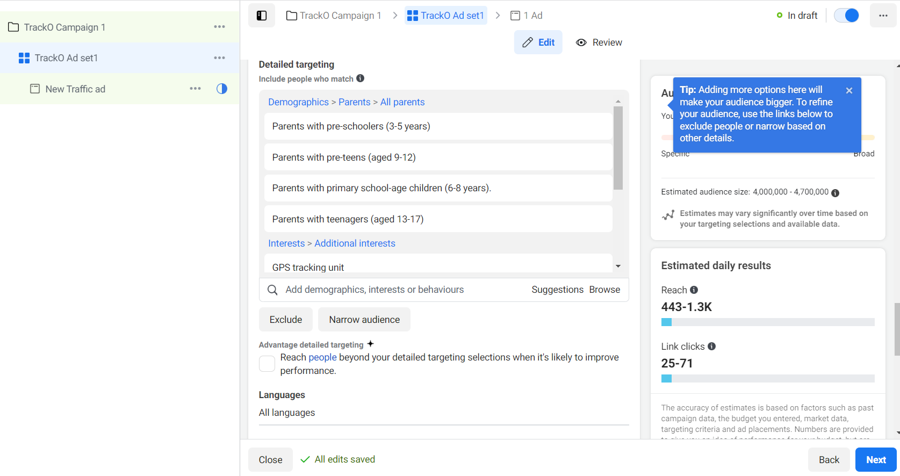

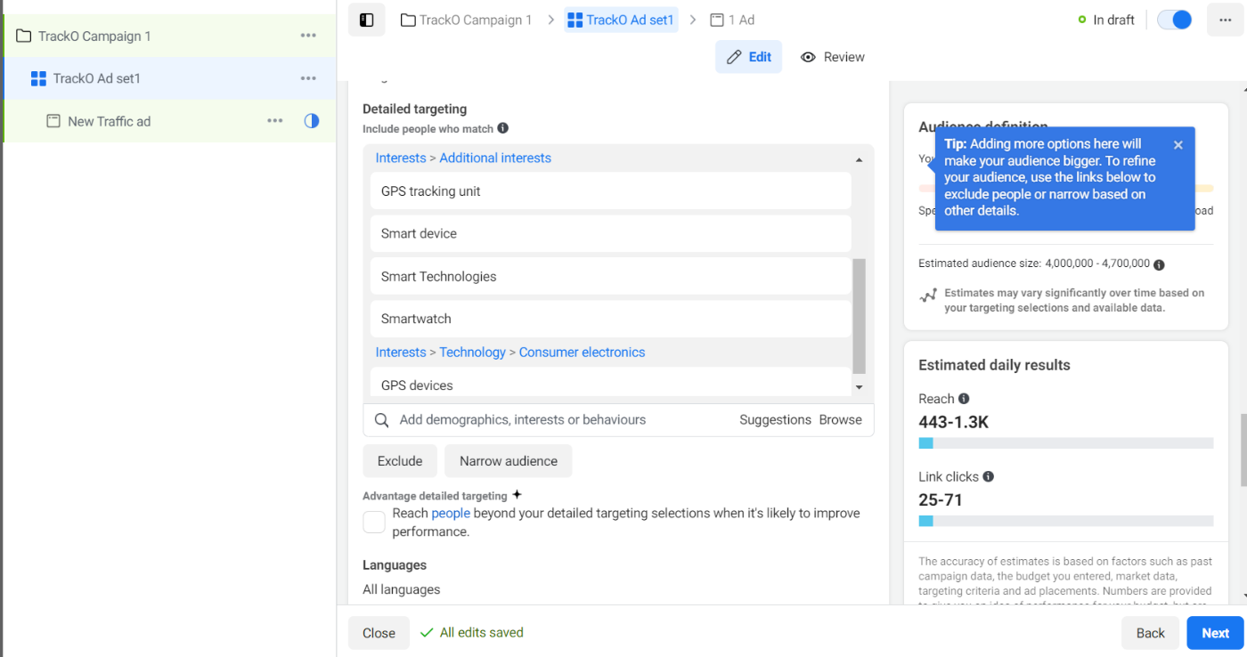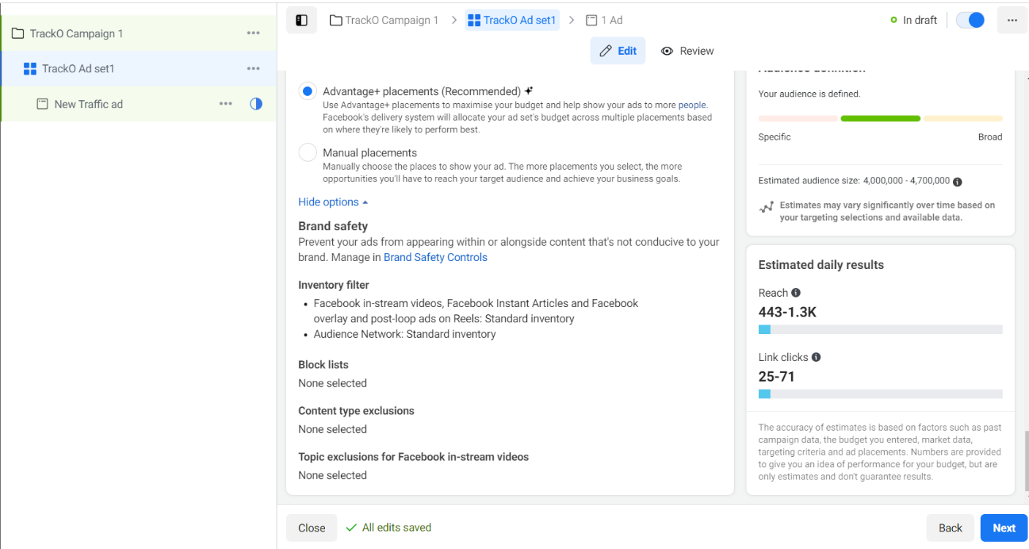

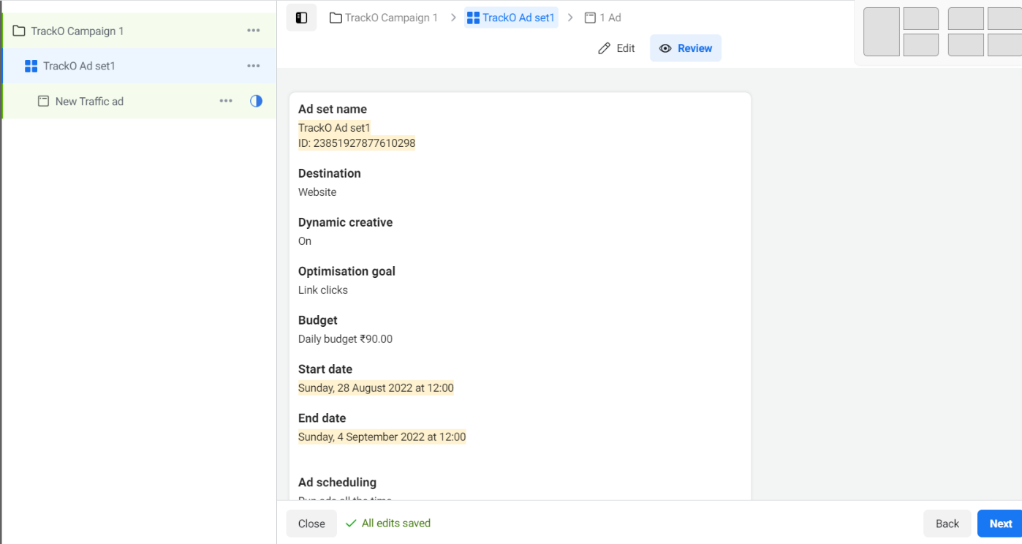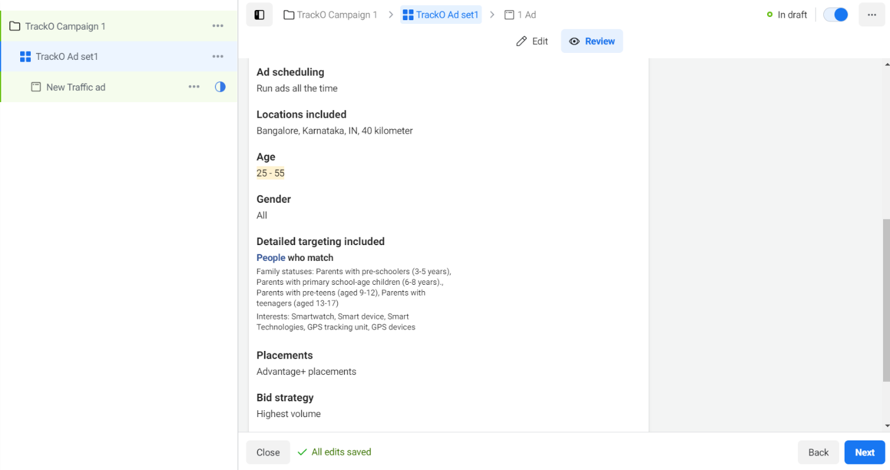

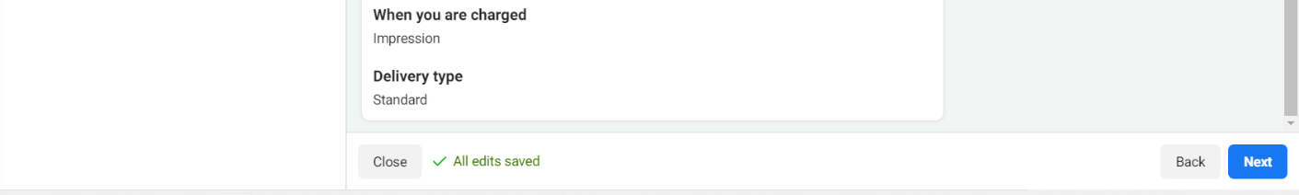

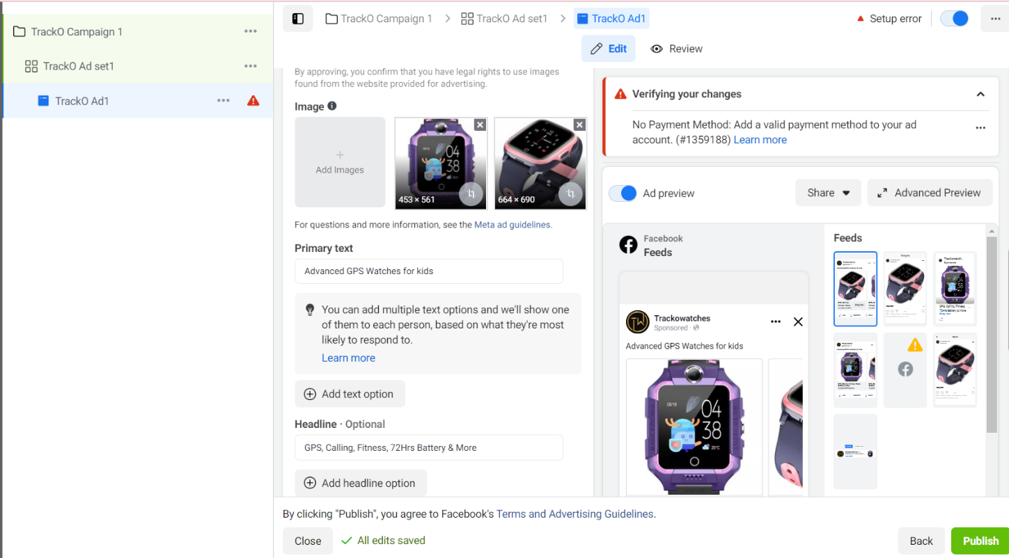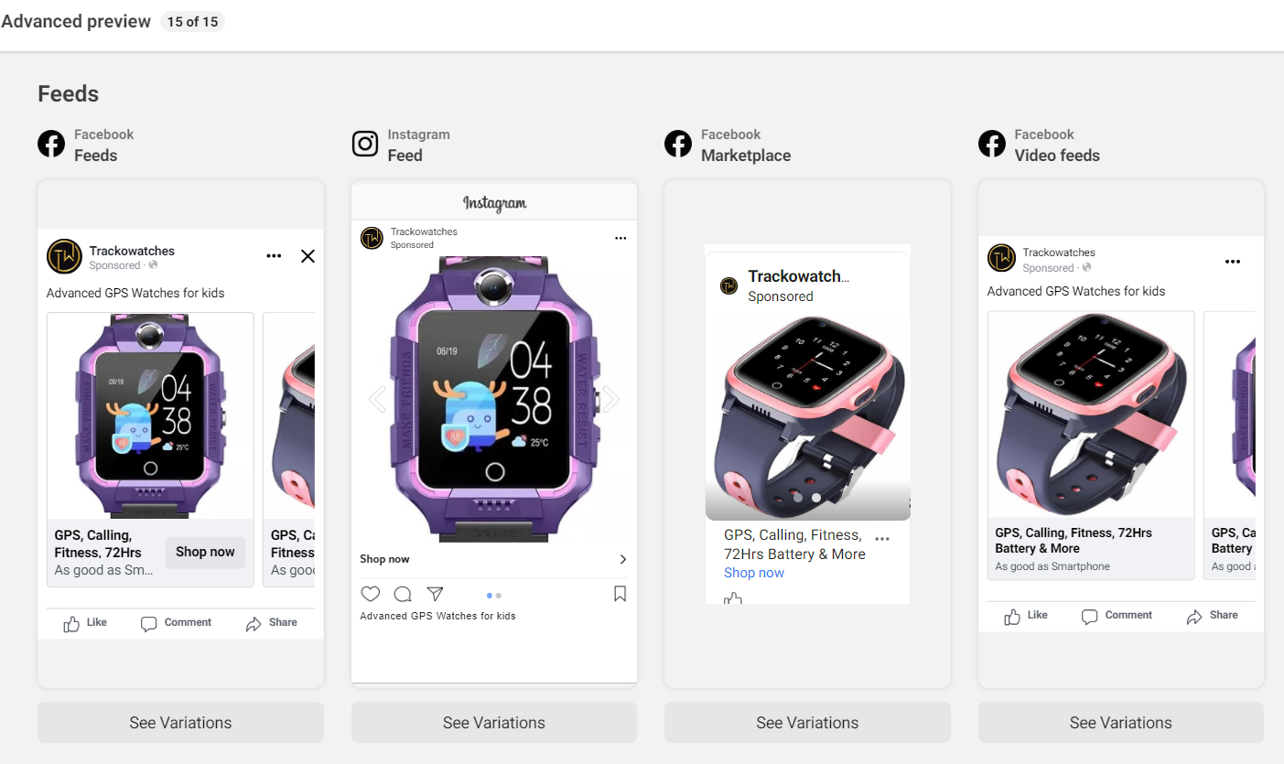

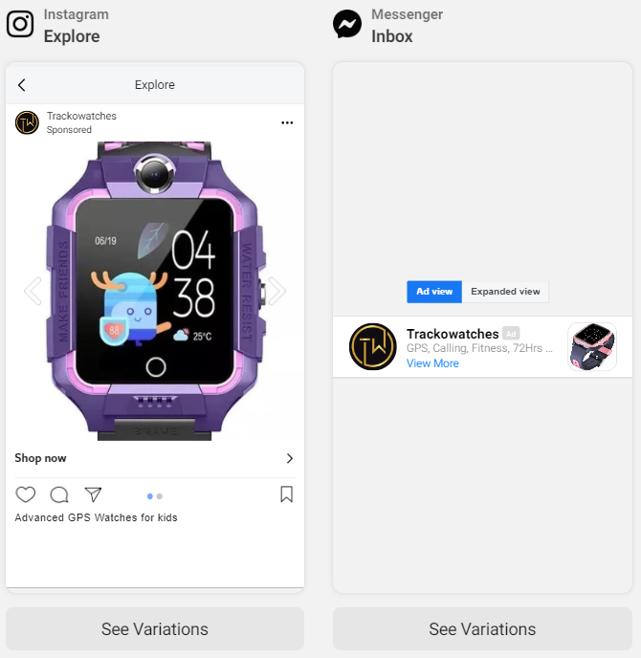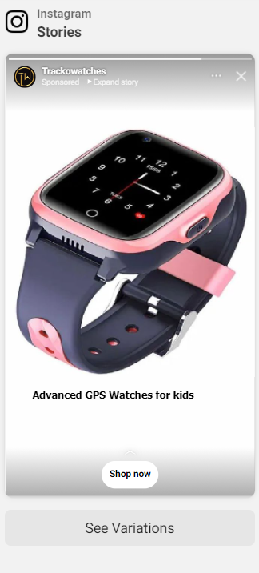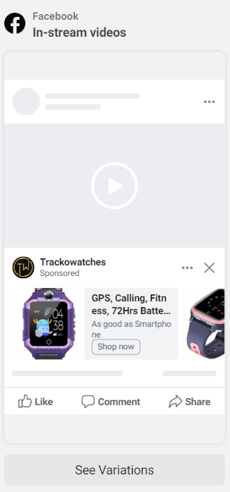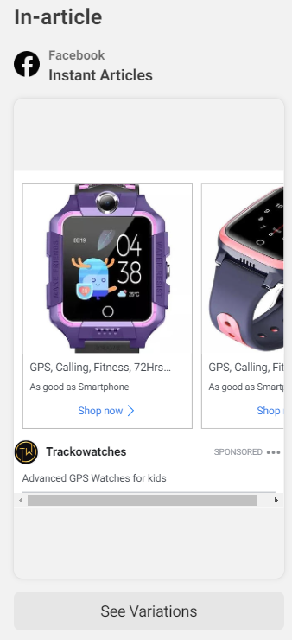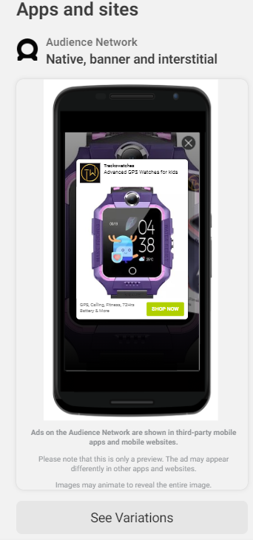

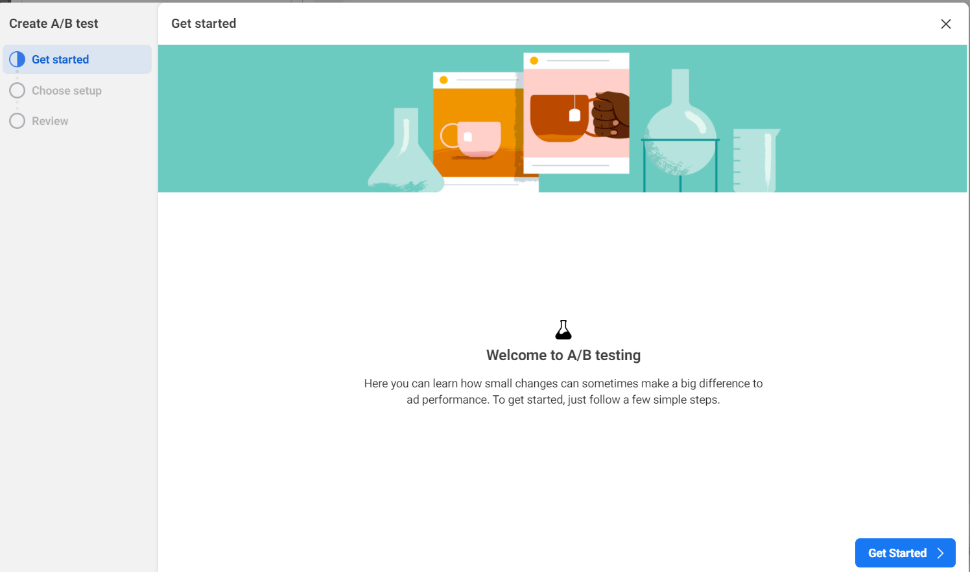

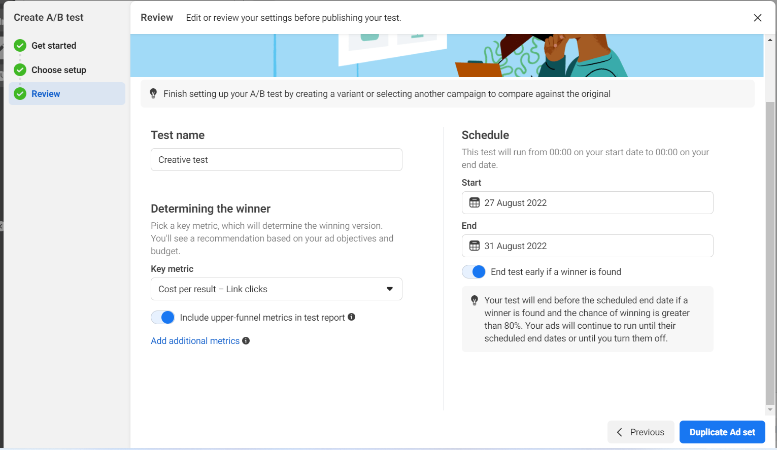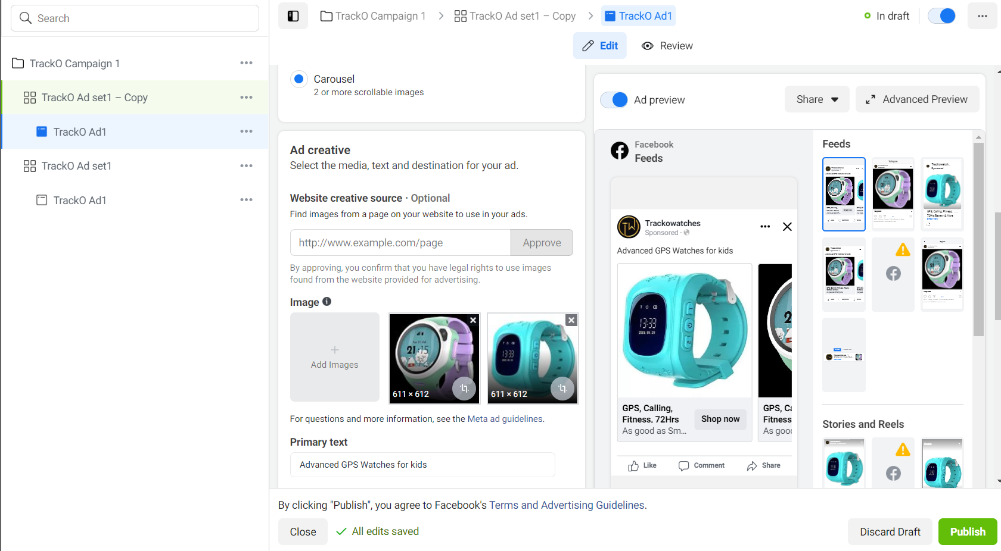

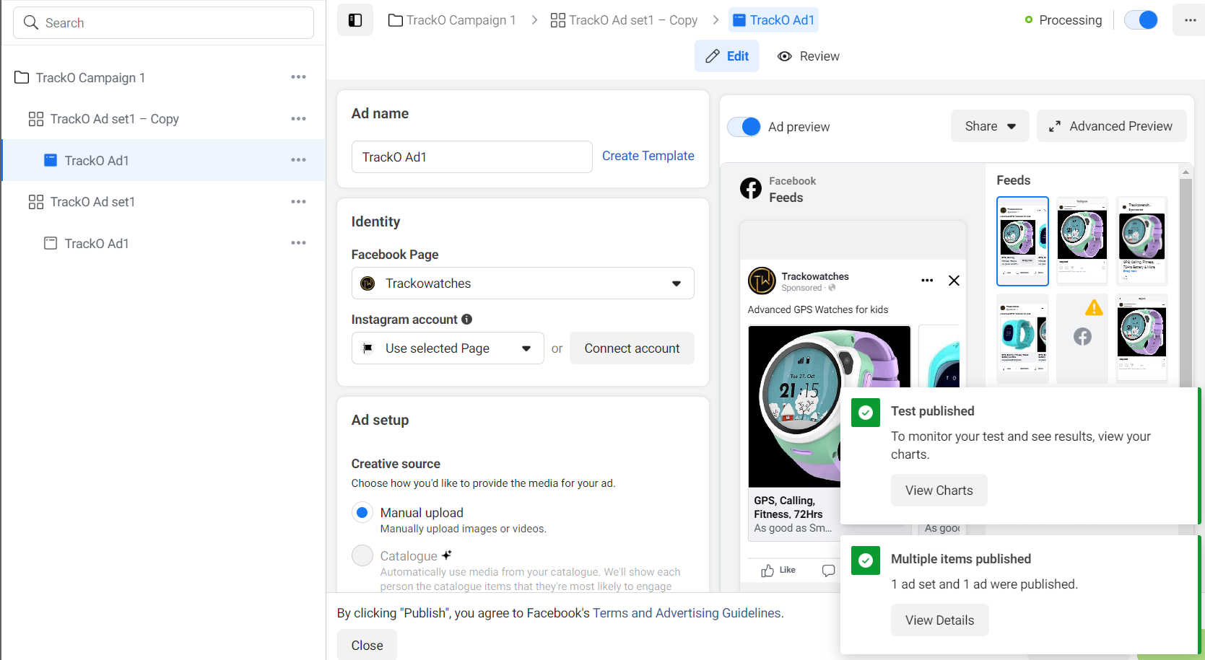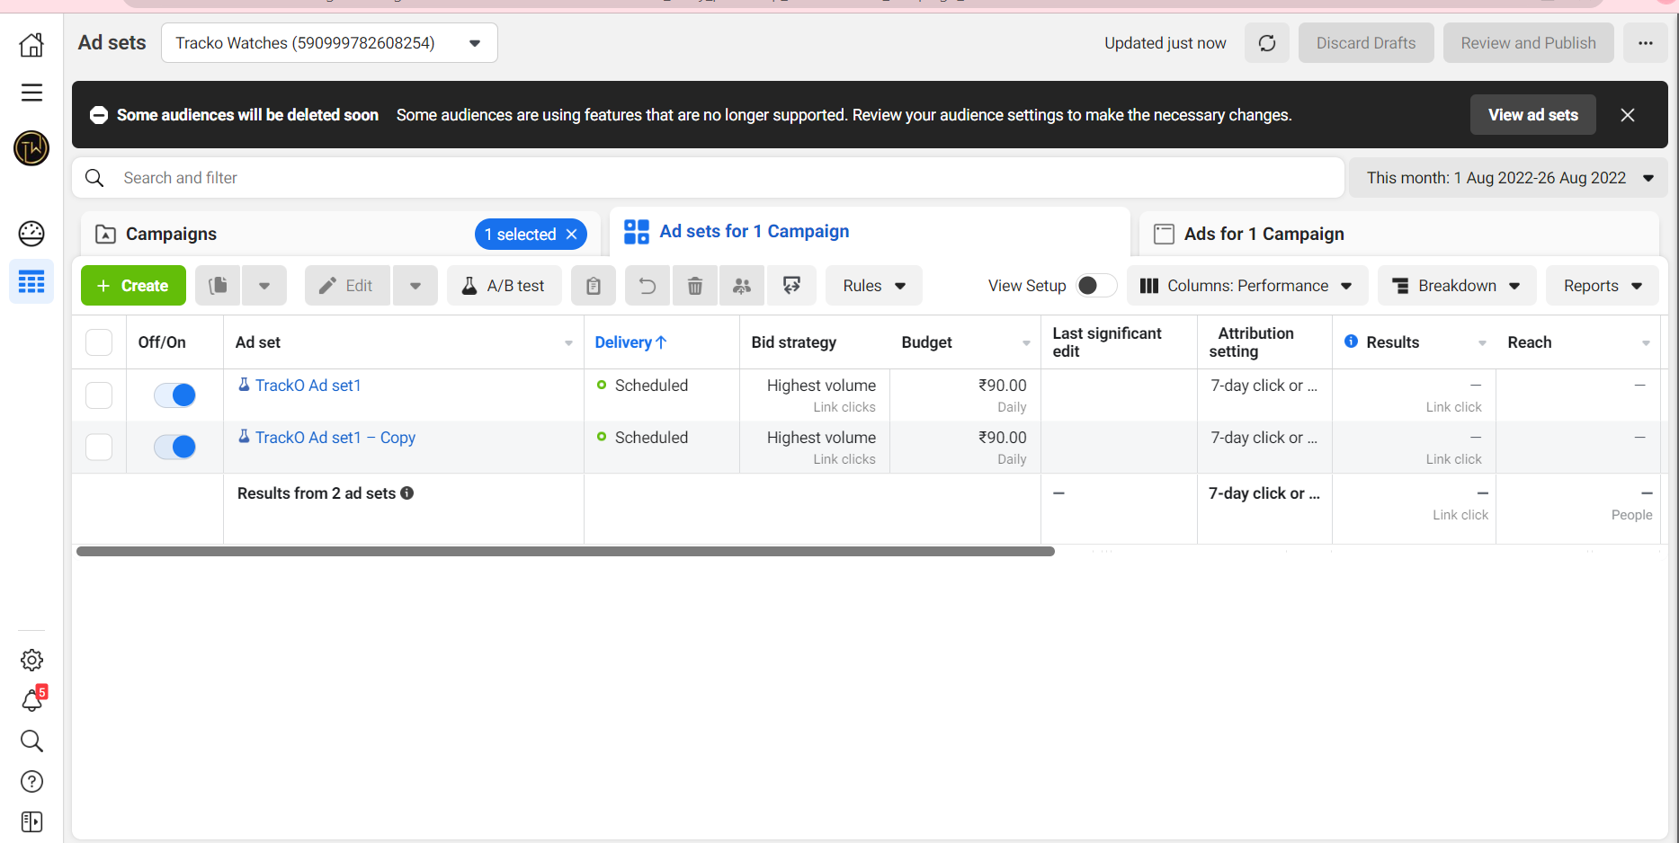

**5.d)** **Screenshots of LinkedIn Ad**



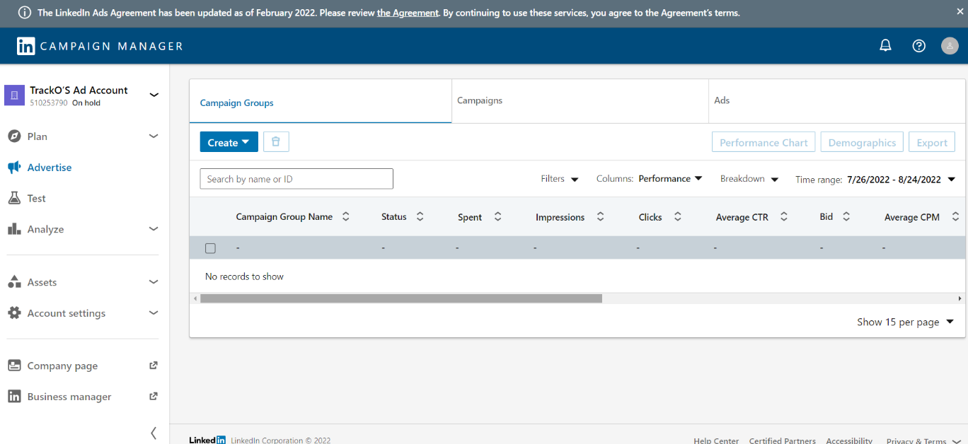

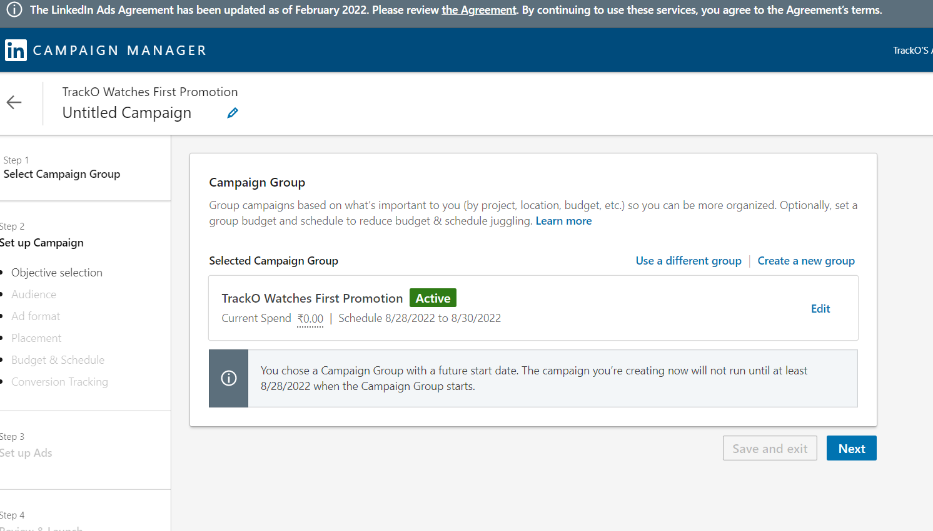

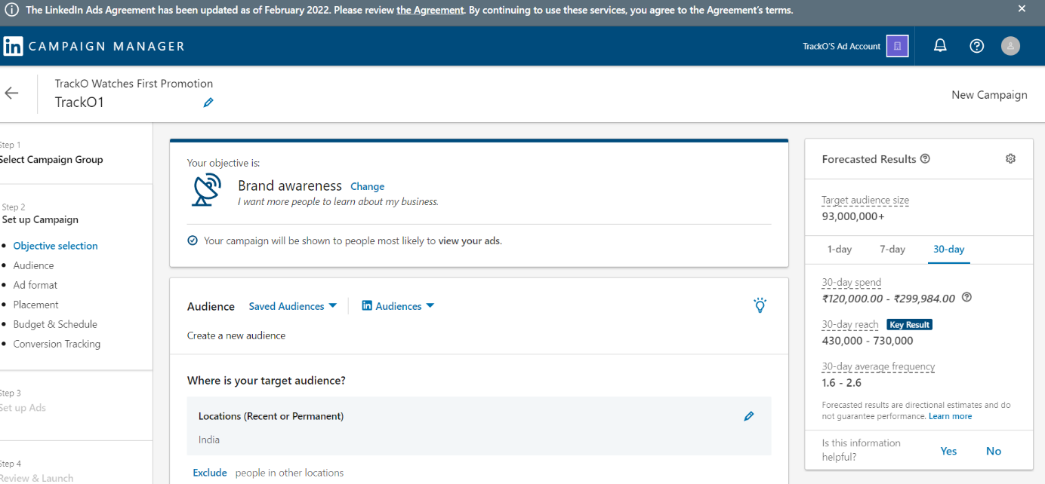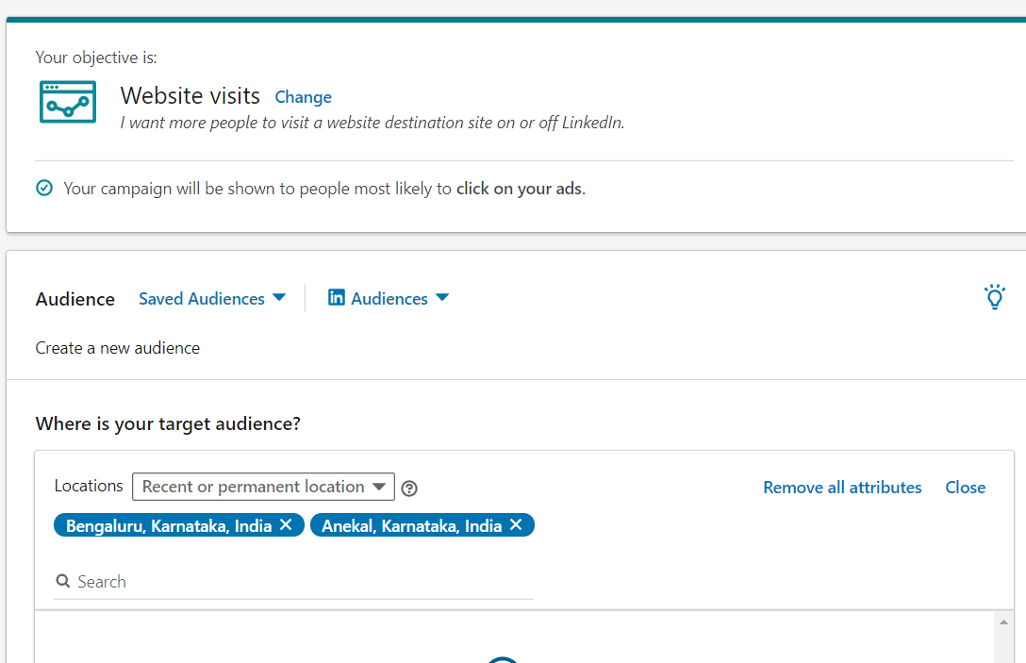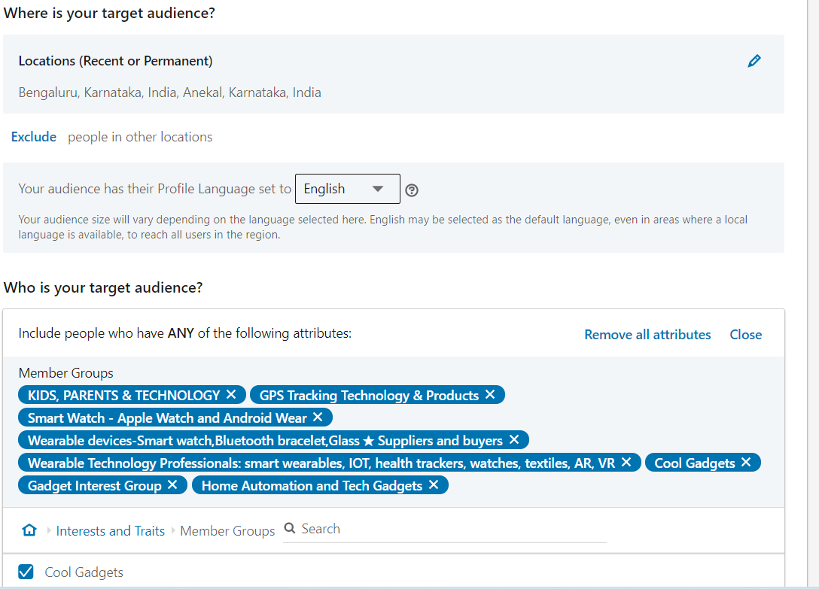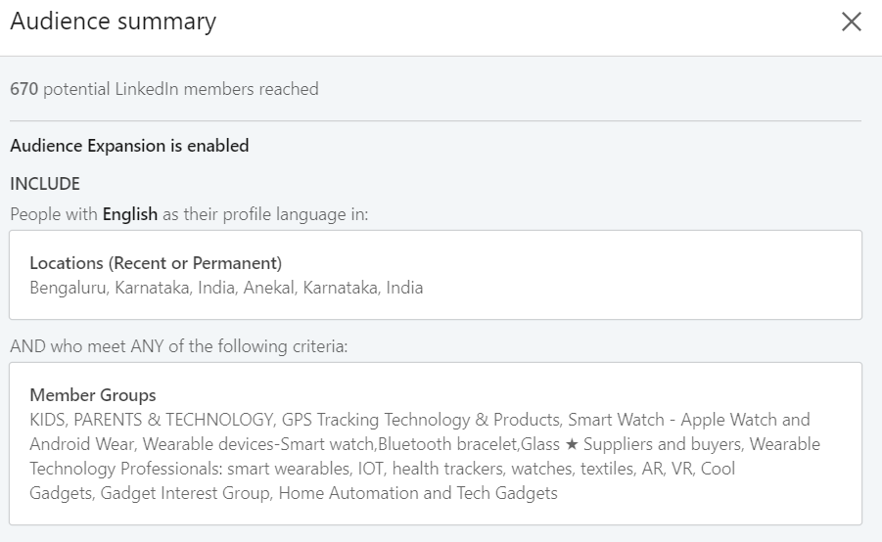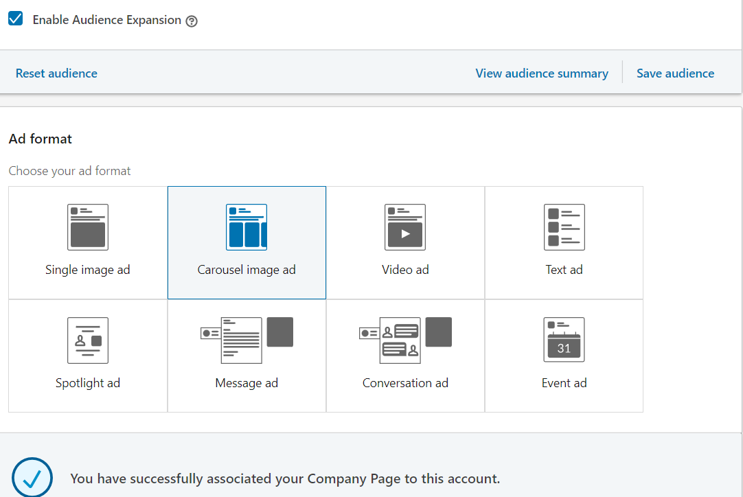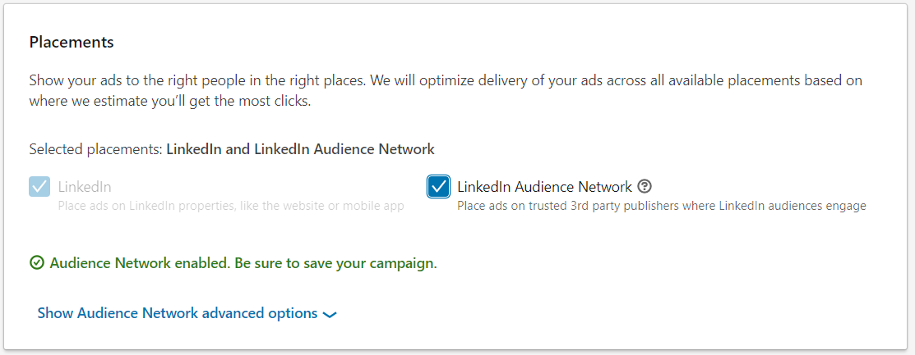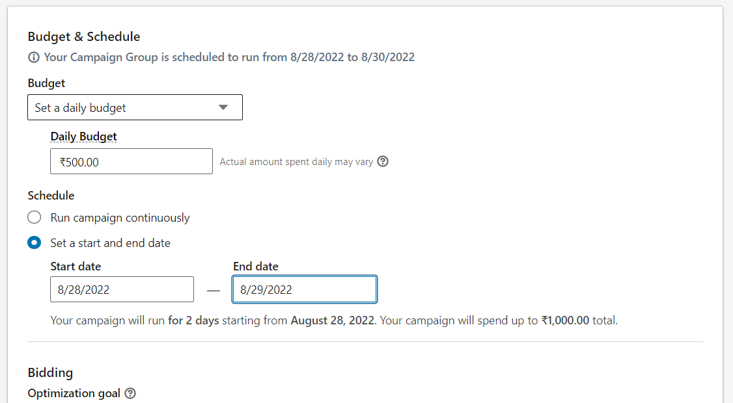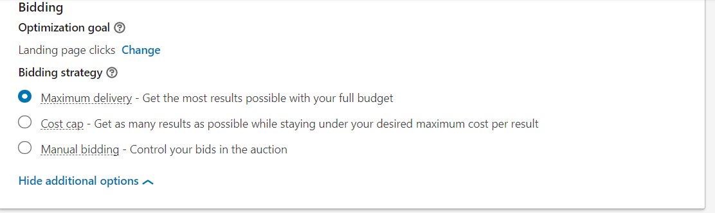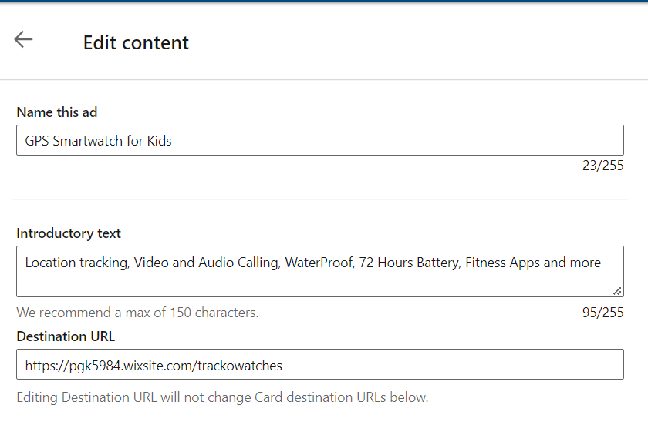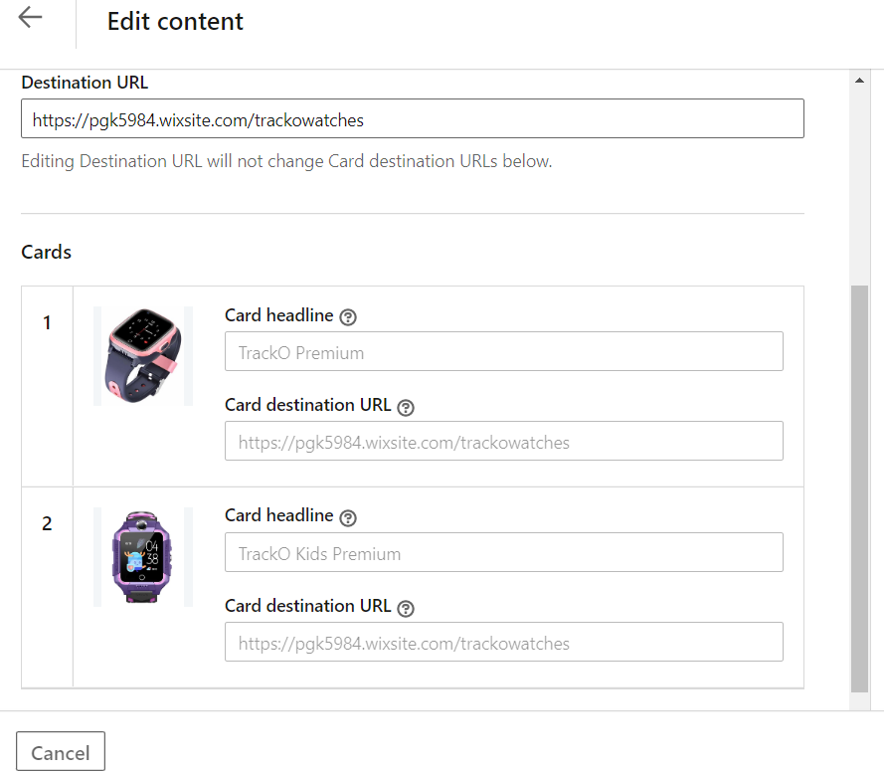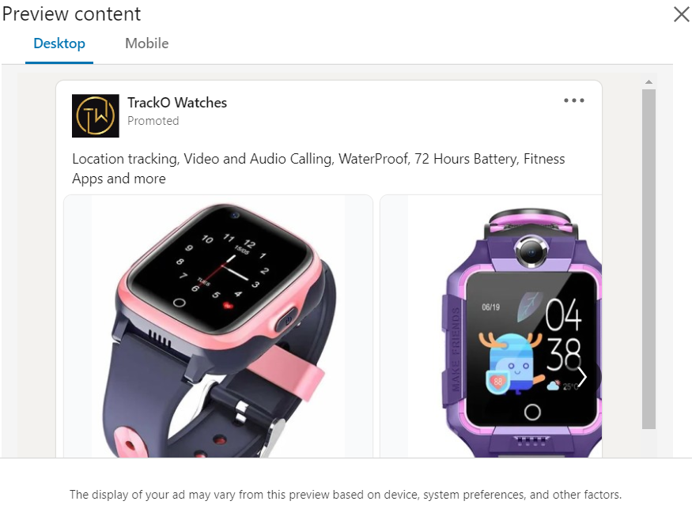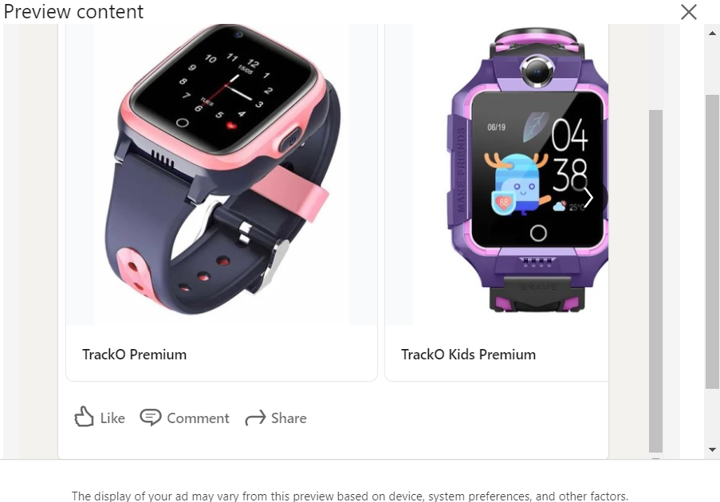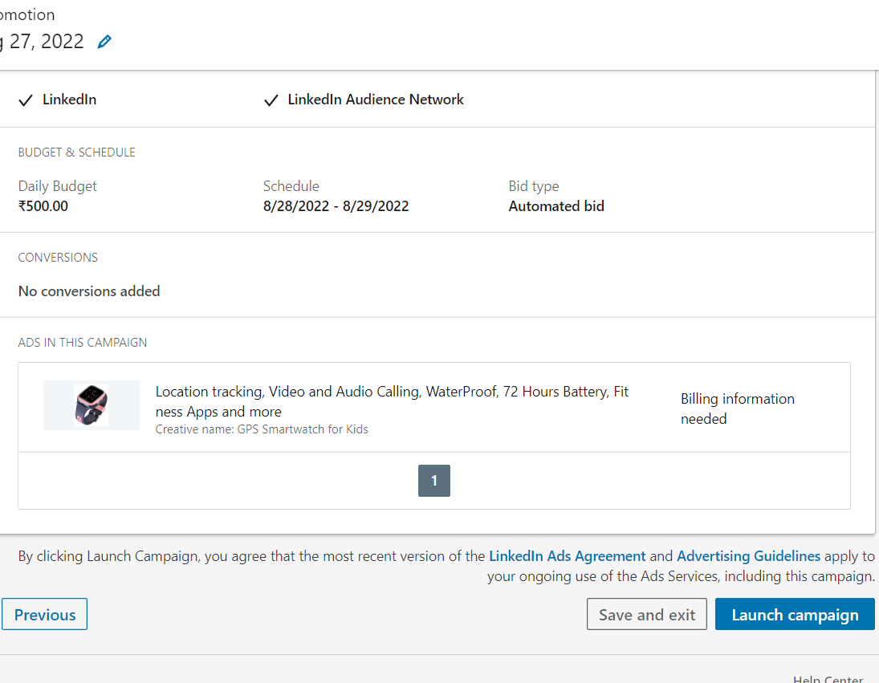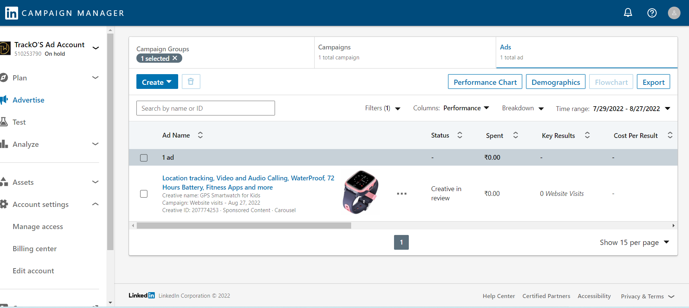

1. **MEASUREMENT OF THE CAMPAIGN PERFORMANCE**

The campaigns are monitored using Campaign Managers of respective platforms. The number of impressions, clicks, Average Cost per Click and the total cost of the campaigns are shown below.

**Google Ad Campaign Manager**

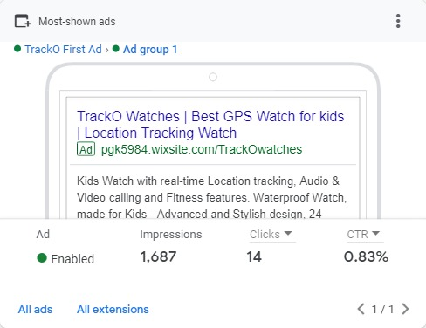

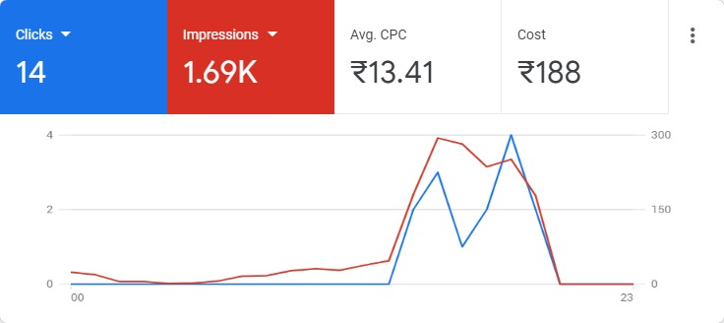

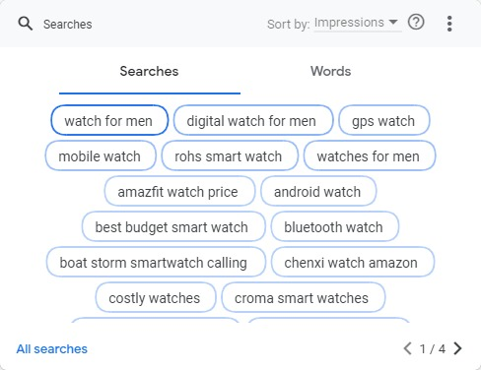

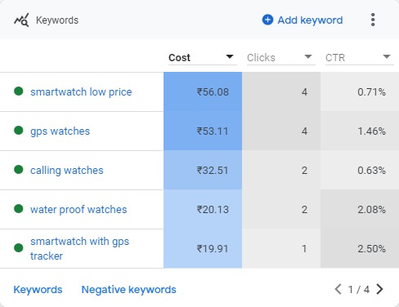

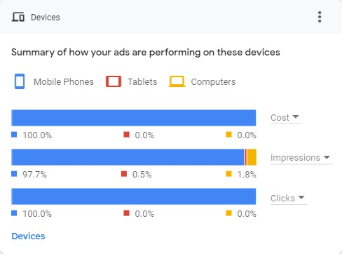

**Facebook Ads Manager**

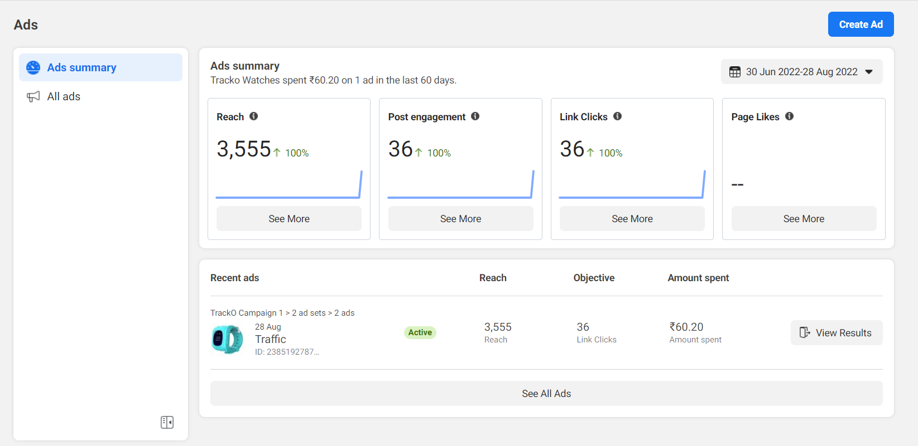

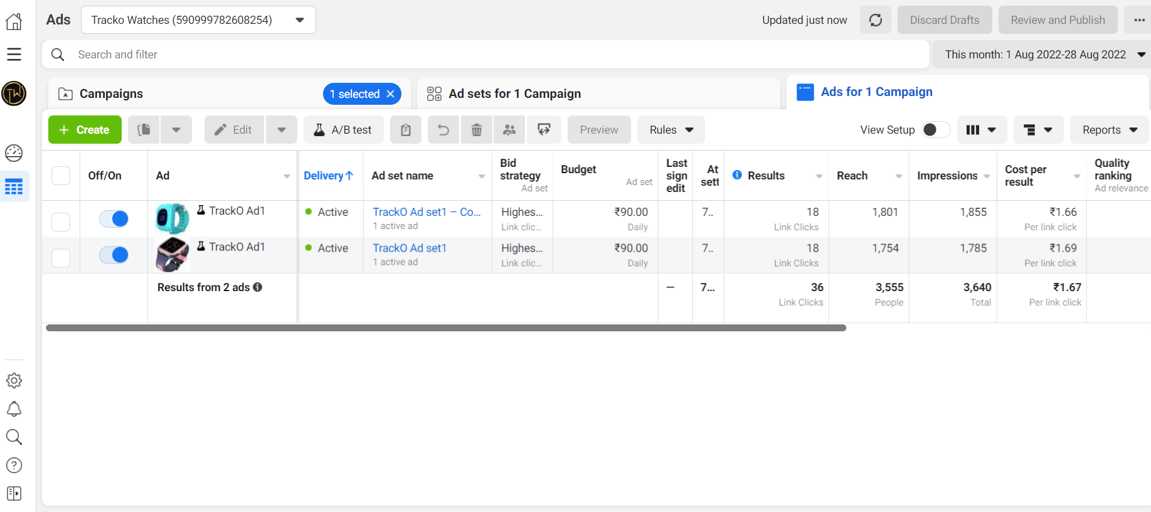

**A/B test results**

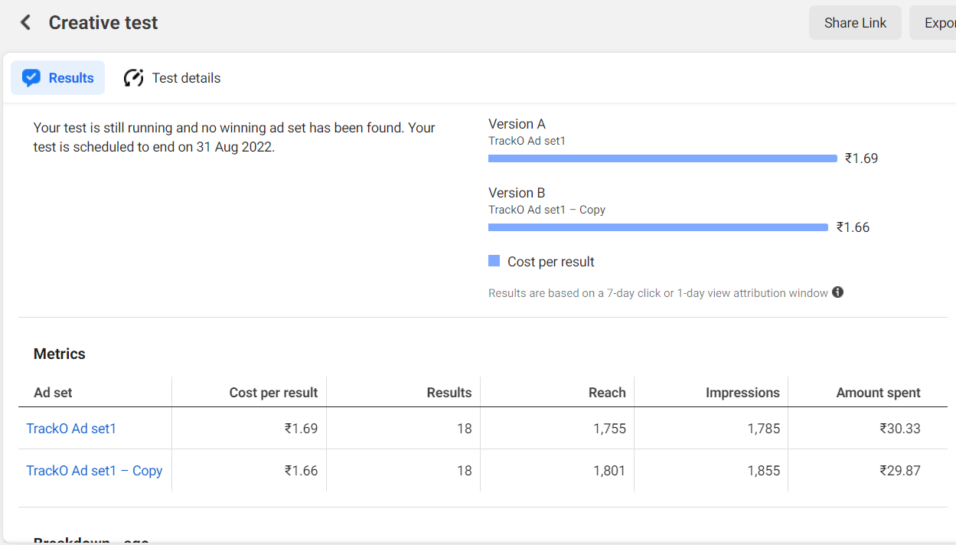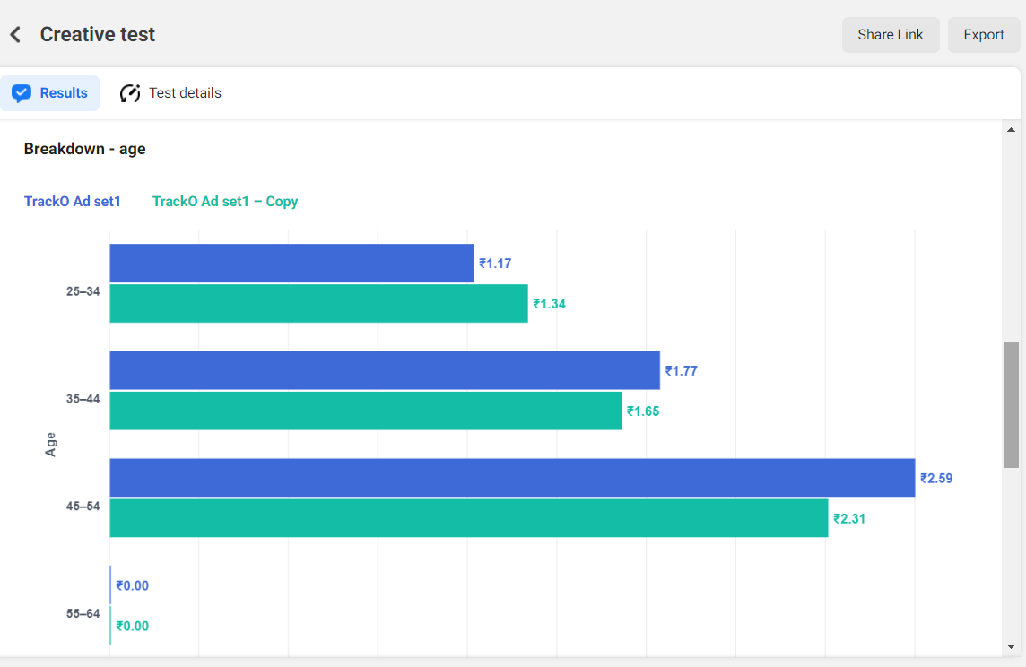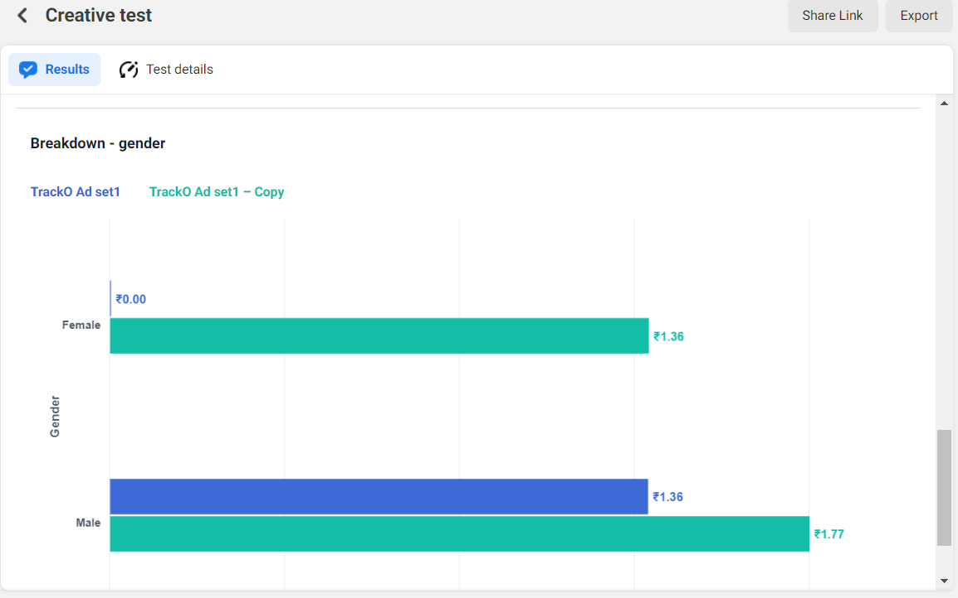

**Youtube Ad Manager**

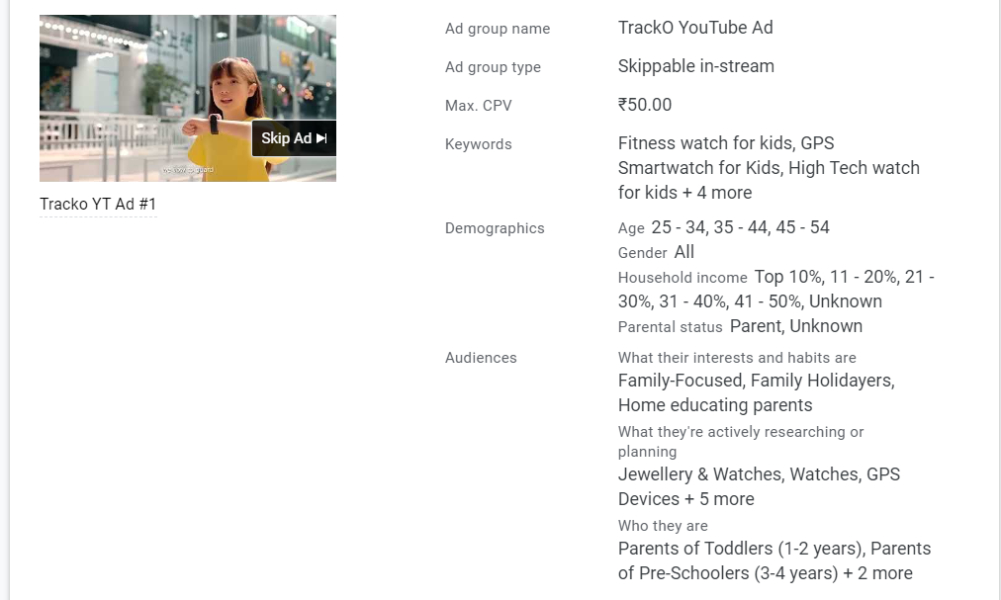

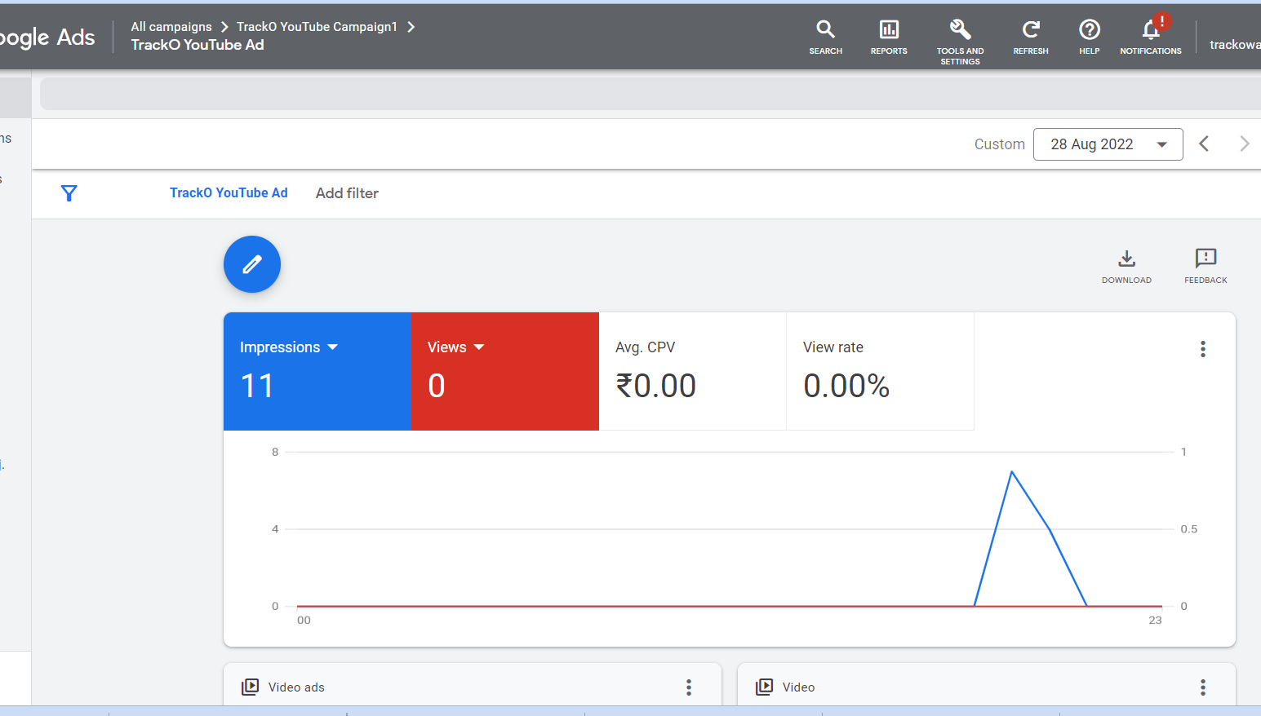

1. **References**

1. Business model canvas created using <https://edit.org/>

2. Google Ad Manager

3. Facebook Ad Manager

4. LinkedIn Campaign Manager

5. Google Search

6. Wixsite

1. **Contribution by Group Members**

1. Poornima Gopalakrishnan

* + Creation of Wixsite/Blog
  + Creation of Google Ad, Youtube Ad
  + Creation of Facebook Account, Facebook Page, Facebook Ad
  + Creation of Linked In Account, Linked In Page, Linked In Ad
  + Report preparation

2. Renu Sree Paruchuri

* + Co-creation of Wixsite/Blog
  + Co-creation of Google Ad, Youtube Ad
  + Co-creation of Facebook Page, Facebook Ad
  + Co-creation of LinkedIn Account, Linked In Page, Linked In Ad
  + Co-creation of report
  + Researching and sharing information on creating various Ads

3. Rohan Nathani

* + Contributing to Wixsite creation
  + Contribution to Youtube Ad
  + Downloading Youtube Video
  + Report Printing from Anekal
  + Sharing Expenses

4. Rahbar Ali

* + Contributing to Wixsite creation
  + Contribution to Google Ad
  + Contribution to Youtube Ad
  + Contribution to Facebook Ad
  + Sharing Expenses